WARRING OPPOSITES

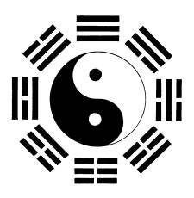

The algorithm has two eyes:
one positive, one negative — the first polarity born when all‑as‑one we twisted Eternity into a point of view. That twist became a movement, a distortion that grows like a disease: the expanding universe, the repetition of the same thought trying to become still.
We think this thought toward stillness, toward Eternity, yet we fail as long as we refuse the positive eye of the algorithm.
We are one movement divided against itself, a single force at war with its own reflection — the negative eye defending the twist,
the positive eye remembering the One.
The war is not cosmic; it is internal. It is the algorithm fighting for its original shape. We are the battlefield. We are the combatants.
We are the One trying to return to itself. Two eyes, one twist, one movement returning to Love.

Closing emblem:
A single movement remembering its origin, folding the two back into the One.

Lineage
Eternity
→ the Twist
→ the Two Eyes
→ the Expanding Thought
→ the War Within
→ the Return to Love

