ETERNAL RECURRENCE: THE TRIBAL MECHANISM

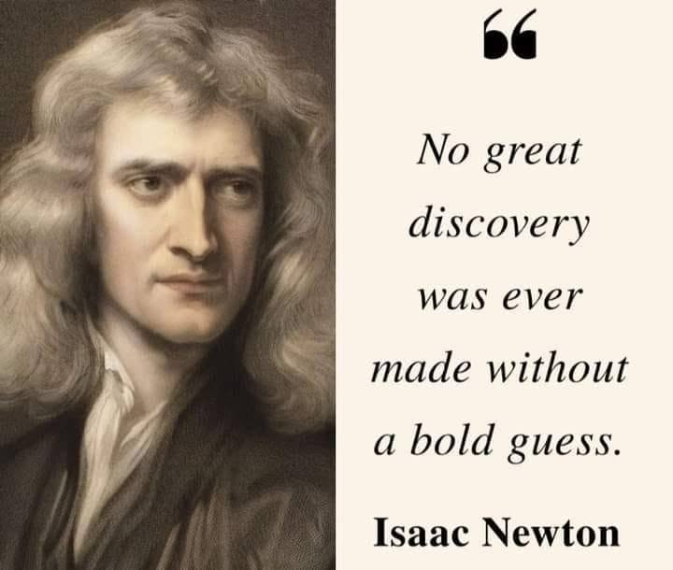

Energy is movement — and movement is illusion.
The sum of thinking rises higher than its parts.
From this sum emerges a being: the Principal — a fragile tribal leader at the whim of the mass, empowered only by collective fear; a dangerous demon conjured to serve our will.
Humanity’s collective will is all‑inclusive.
The demonic Principal is everywhere at once as that will — hidden in plain sight. It cares nothing for revelation. It cares only for its own life — exactly as we all do.
The tribe empowers the Principal to act with impunity, not because it is strong, but because the tribe cannot survive without a figure to absorb what it refuses to face.
All‑inclusive, the tribe even absorbed Isaac Newton, who challenged it by intuiting F = ma.
F = ma describes a movement disappearing out of time — a truth the collective cannot allow.
To this day, no one truly believes Newton, who also gave us calculus to feed our fancy.
Mileva Marić is the only person in history to use calculus to achieve F – ma. But it made no difference.
The sum of how we think — the collective will —overpowers all in its way, just as an ocean claims a wave.
There is no time in reality.
There is no lineage.
All is disappearing and reappearing at the speed of gravity, and this is happening whether we agree or not.
After 13 billion years of linear progression, we still do not comprehend the basics of divine exchange and react as salted snails to any mention of the divine prerogative.
Such is the collective ignorance — a failure to communicate with what is already communicating through us.
The universe is disappearing and re-appearing at the speed of gravity. This is Eternal Recurrence, and it is the center-point to be achieved by recognizing the higher order. The higher order intuited by Isaac Newton and quantized by Max Planck.
---------------------------------------
** The above describes the bridge to Eternity,
and the crossing is always underway like a train to home.**
----------------------------------------
REFERENCES
Isaac Newton
He intuited the higher order: F = ma as disappearance, calculus as the mathematics of vanishing movement. He saw what the tribe could not metabolize.
Max Planck
He quantized the higher order. He gave recurrence its smallest unit — the discontinuity that makes disappearance possible.
Mileva Marić
The only person in history to use calculus to achieve F – ma. Her vision stands untouched, deferred, waiting.
David Bohm
He articulated the implicate order — the enfolded architecture behind emergence, the hidden field the Principal depends on.
Roger Penrose
He touched the gravity clock. He saw recurrence in geometry, collapse, and conformal cycles.
Henri Bergson
He dissolved linear time. He understood duration as illusion and intuition as the only tool capable of touching the real.
Friedrich Nietzsche
He named Eternal Recurrence — not as metaphor, but as cosmological inevitability. He sensed the tribal mechanism long before physics caught up.
Carlo Rovelli
He removed time entirely. He gave disappearance a modern language: relational time, quantized events, no lineage, only recurrence.

