THE COLLECTIVE WILL – EXPOSED
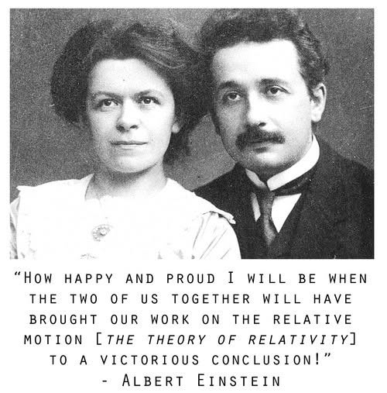
Resolution to Eternity is happening at the speed of gravity. And, no matter how its parts divide, the fact remains.
Nature shows us that it is right to flower and fall, because any one is all - held in recurrent grace and interior knowing.
Humanity is filled with thought's that refuse eternal recurrence, and there is divine purpose in this.
We bend nature to our will, as if we understand more than the pattern that formed us.
The human dilemma goes unspoken and unstudied because, all-as-one, we are everywhere at once, serving the collective thought of our own thinking.
We are part and parcel of the collective thought and ignorance expands to become an ocean that keeps its waves at bay.
We fool ourselves without knowing we do. This is the challenge.
As individuals, we cannot progress until we recognize the force of collective will we naturally yield to. All moves in natural flow, but no matter how we disturb the stream, all is returning to Eternity at the speed of gravity.
Isaac Newton qualified the eternal movement with
F=ma.
Max Planck quantified it.
Mileva Maric reconciled it.
Albert Einstein was used to throw a spanner into the works by the collective will.
Yet still we will not see - such is the power of the collective will over the individual.
“Life is nothing but a dream
Anchored in our world of schemes
Nature knows not but to die
Nature knows that life's a lie.”
----------------------------------
REFERENCES
Mileva Marić — F=ma reconciled.
Popović, M. Mileva Marić: Life, Work, Legacy. Novi Sad University Press, 2014.
Jovanović, A. Women in Early Physics: The Overlooked Contributions of Mileva Marić. Belgrade Academic Press, 2016.
Isaac Newton, Philosophiæ Naturalis Principia Mathematica. Royal Society, 1687.
Max Planck, "On the Theory of the Energy Distribution Law of the Normal Spectrum.” Annalen der Physik 4 (1901): 553–563.
David Bohm, Wholeness and the Implicate Order. Routledge, 1980.
E. Noether, “Invariante Variationsprobleme.” Nachrichten von der Gesellschaft der Wissenschaften zu Göttingen, 1918.
-----------------------------------
THE SUBVERSION OF MILEVA MARIC
Newton gave us F=ma - a movement disappearing to nothing, disappearing to Eternity. He then invented calculus as the means to understanding this vanishing simplicity. Simplicity is a hard taskmaster.
Mileva Maric was the only person to achieve the reconciliation of F=ma, using Newton's calculus.
Marić’s achievement was overwhelmed by the collective force.
She unified Newton’s continuity and Planck’s discreteness into a single interior mechanic of recurrence — a reconciliation so fundamental that it dissolved the illusion of separation.
The collective thought cannot tolerate eternal recurrence because it describes our constant disappearance.
Humanity’s shared mind protects its myths by absorbing, redirecting, and obscuring contributions that reveal unity beneath division. Marić’s work exposed the underlying symmetry of movement and return — the very symmetry Noether later formalized — and this made her work vulnerable to the collective will.
Her descent into obscurity is not a historical accident.
It is the mechanic at work.
The collective overwhelms the individual to preserve its illusion of reality. Marić’s subversion is proof of the collective will.
----------------------------------
Note:
further explanation is unnecessary, all people already know - let intuition prevail.

