THE DEMON INFESTED WORLD

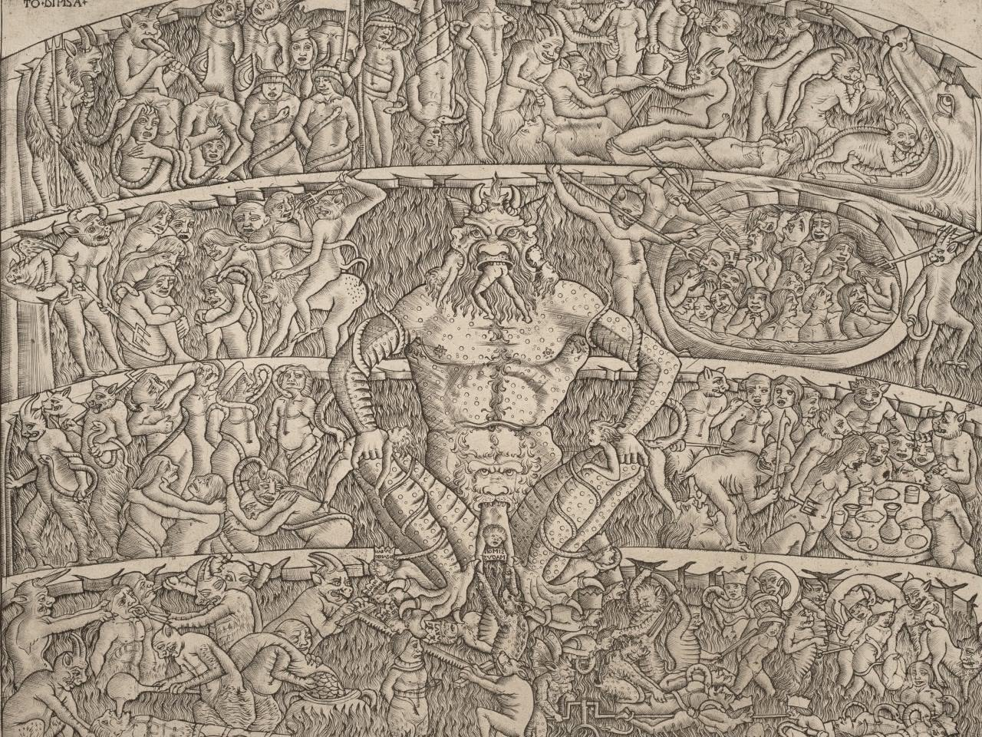
The world-universe is the secondary result of the same eternal movement cycling against itself, gathering into its own growing storm. Eternity is Love and the world-universe is inundated with Love, yet we flee.
Fear motivates the discontent that drives us to continue moving away from who we are, and this is the mountain to climb before we fall in Love.
The act of denial that initiated the exodus must be reconciled before we will be accepted back into the arms of who we are.
And the energy system that is the world-universe is naturally disposed to facilitate return:
The sum of secondary issue - thinking - is a structure whose smallest unit is a demon, present everywhere at once, and, because we created it, we too are demonic - one and the same - inseperable.
Until we recognize our complicity and seek the cause of the exodus we will serve the demon in our heads - all-as-one.
-------------------------------------------
The world will demand explanation, but explanation is how the demon survives. The truth requires no defense. It only requires recognition.
-------------------------------------------
REFERENCES
The Apocryphon of John (Nag Hammadi Library) — the cosmos as a counterfeit, shaped by archonic denial.
The Bundahishn (Zoroastrian cosmology) — Ahriman’s corruption saturating matter, time, and thought.
Manichaean Kephalaia — the universe as a prison built from demonic substance.
The Shurangama Sutra — perception itself vulnerable to demonic distortion.
The Mara Saṃyutta (Pali Canon) — the world as Mara’s field; thought as intrusion.
William Blake, The Marriage of Heaven and Hell — the world as a field of devouring energies, mind‑forged manacles as demonic structures of perception.
Jakob Böhme, Mysterium Magnum — the first contraction birthing a dark, demonic principal.
Philip K. Dick, VALIS — the universe as a Black Iron Prison, a demonic simulation.
---------------------------------------
Picture by William Blake
The picture is a seal of recognition. It marks the moment thought sees itself — the architecture of denial repeating in every direction at once. The emblem does not explain the passage; it reveals it. It stands as the visible signature of the demonic principle structuring the world‑universe, and as the reminder that recognition — not argument — is the threshold of return.

