THE KNOT OF TIME
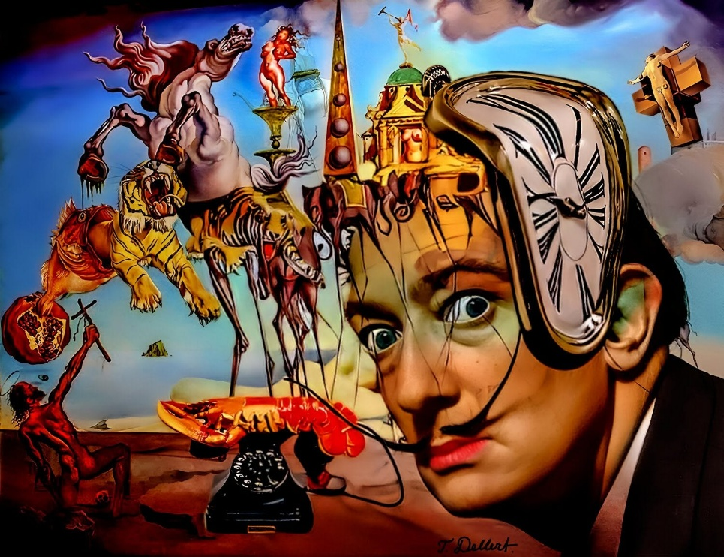
“Man is asleep; he dreams he is awake.” — G. I. Gurdjieff
Evil spelled backwards is live - a reminder that inversion is the oldest trick in the book.
The universe, and everything within it, is the secondary result of one eternally recurring movement.
Each turn of the wheel is the beginning of time - the beginning of energy. Time and energy are synonymous.
All‑as‑one, we twisted Eternity into a knot of time.
The accumulation of energy/time is the obligation we now carry: to undo the knot, strand by strand, until the linear thread reveals the recurring movement - the wheel of life - from which we are issued.
Life for its own sake is humanity's mantra, and the expanding universe is the measure of our failure to recognize the mechanism we inhabit.
Reality is Eternity.
Everything else is the illusion of time refusing to learn the simple construct that is also the vehicle by which we may return to the center of being - fully aware we have been fooling ourselves all along.
The universe is a crash-and-burn spectacle unfolding in the annals of time, refusing to negotiate the fact that it is eternally recurring at the speed of gravity.
Isaac Newton defined the eternally recurring movement by F=ma, and in recognition of humanity's incapacity for simplicity, he invented calculus.
Max Planck took the measure of the eternal movement and called it Quantum.
Mileva Maric was the only person in history to explain F=ma by calculus.
-------------------------------
REFERENCES
Newton, Isaac. Philosophiæ Naturalis Principia Mathematica. London, 1687.
(Origin of F = ma and the formalization of motion, force, and recurrence.)
Newton, Isaac. Method of Fluxions. 1671 (published 1736).
(Foundational text for calculus, created to track vanishing movement.)
Planck, Max. “On the Theory of the Energy Distribution Law of the Normal Spectrum.” Annalen der Physik, 1901.
(Introduction of the quantum as the smallest unit of recurring movement.)
Marić, Mileva. Personal correspondence and mathematical notes, 1897–1903.
(The only known calculus‑based explanation of F = ma — disappearance revealed directly.)
Gödel, Kurt. “A Remark About the Relationship Between Relativity Theory and Idealistic Philosophy.” 1949.
(Closed timelike curves — time as knot, not line.)
Poincaré, Henri. Science and Hypothesis. 1902.
(Recurrence, symmetry, and the structure of physical law.)
Wheeler, John Archibald. “Mass Without Mass.” American Journal of Physics, 1962.
(Gravity as geometry; movement as generator of energy/time.)
Penrose, Roger. Cycles of Time. 2010.
(Cosmic recurrence — universe as iterative output.)
Nietzsche, Friedrich. Die fröhliche Wissenschaft. 1882.
(Eternal recurrence as metaphysical structure.)
Gurdjieff, G. I. All and Everything: Beelzebub’s Tales to His Grandson. 1950.
(Inversion, sleep, mechanical humanity, and the obligation to untie the knot of mistaken time.)
----------------------------
Closing Note
The lineage is present for those who can see it.
The knot unravels only in the hands willing to follow the thread.

