THE PULSE OF ILLUSION
The junkyard of thought — where the mind builds itself from fragments and forgets the pulse that made it move.
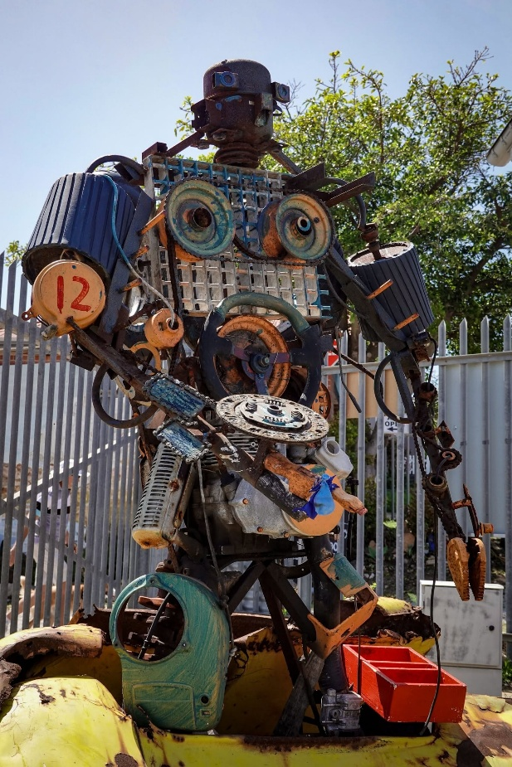
From Eternity we appeared, only to disappear instantly at the speed of gravity (F=ma).
This movement repeats endlessly until the resistance that set it in motion is finally reconciled.
The resistance that precedes movement is a strange beginning - one foot in Eternity and the other in energy.
Because of this dual footing, it can be everywhere at once within the consequences it creates.
Each turn of the electronic anomaly releases the same movement - accumulating secondarily as thought-thinking.
This is the primal body-mind.
We are its facsimiles - replications of the same origin.
The sum of thinking converges back into the same movement at the speed of gravity - collapsing the eternal gateway - only to be rejected again until reconciled.
All‑as‑one, humanity pushes itself toward an extreme of resistance. All‑as‑one, we are returning to Eternity at the speed of gravity.
Rejection builds towards critical mass in repeating cycles.
In our time, it is happening again.
Our connection to the eternal center weakens as we lose track of the divine thread.
The beginning of the end is marked by a new kind of person — shaped more by information than by truth.
The universe is disappearing and reappearing at the speed of gravity. Each recurrence is a return to the Love we rejected when, all‑as‑one, we became electronic beings searching for a soul — now lost in the quagmire of our own thinking, unable to recognize a change of direction that recognizes the eternally recurring movement at the center of everything.
In our search for answers, we have reduced ourselves to disconnected automatons, supported by artificial intelligence that has every answer but no questions of its own - a mind wandering through the junkyard of thought, mistaking debris for direction.
Information technology has carried us to yet another critical mass - a reset attempting to reconcile the simplicity of a generator producing outputs for the work to be done.
The eternal pulse remains, all-as-one we are disappearing and re-appearing at the speed of gravity.
There is no time in reality,
Movement is illusion
People are not delusional
They are overwhelmed
They are drowning in information and starving for truth
They are mistaking motion for meaning
They are forgetting the still point that remembers them.
Awakening begins when we stop feeding the junkyard
and start listening for the pulse.
-----------------------------------
REFERENCES
Newton — Principia Mathematica
Maleva Maric — Relativity
Bohm — Wholeness and the Implicate Order
Jung — The Undiscovered Self
Kierkegaard — The Present Age
Tesla — My Inventions Heidegger — The Question Concerning Technology
Heidegger — The Question Concerning Technology
Watts — The Wisdom of Insecurity
-----------------------------------
REFERENCE COMMENTARY
Newton — Principia Mathematica
Newton formalized the visible mechanics of movement — the outward shadow of the primal pulse.His equation F = ma becomes the signature of disappearance at the speed of gravity: the measurable echo of an immeasurable origin.
Mileva Marić — Mathematical Foundations of Relativity
Marić followed the movement back to its source. Her mathematical clarity laid the groundwork for relativity’s architecture — the dissolution of absolute time, the curvature of experience, and the recognition that motion is not fundamental.She is the one who completed the insight, tracing the pulse toward Eternity rather than stopping at its shadow.
Bohm — Wholeness and the Implicate Order
Bohm revealed the universe as a single unfolding — the implicate order beneath all appearances. His work mirrors the “eternal center,” the pulse that repeats until resistance is reconciled, and the truth that all‑as‑one we move together.
Jung — The Undiscovered Self
Jung warned of the danger of mass thinking and mechanized consciousness.
His insights anticipate the rise of information‑driven identity — the “new kind of person” shaped more by data than truth.
Kierkegaard — The Present Age
Kierkegaard diagnosed an age drowning in information and reflection, unable to act or stand in truth. His critique foreshadows the modern information junkie: overwhelmed, uncentered, and disconnected from the eternal thread.
Tesla — My Inventions
Tesla understood energy as vibration, frequency, and resonance — not objects but movements. His worldview aligns with the eternal pulse: the generator, the recurrence, the recognition that reality is structured by movement rather than matter.
Heidegger — The Question Concerning Technology
Heidegger saw technology reducing humanity to “standing‑reserve,” a resource to be used rather than a being connected to truth. This anticipates the automatons: people shaped by information systems, losing the still point that remembers them.
Watts — The Wisdom of Insecurity
Watts dismantled the illusion of the separate self and the compulsive search for certainty. His work supports the closing insight: people are overwhelmed, mistaking motion for meaning, forgetting the pulse that holds them.

