PROOF POSITIVE
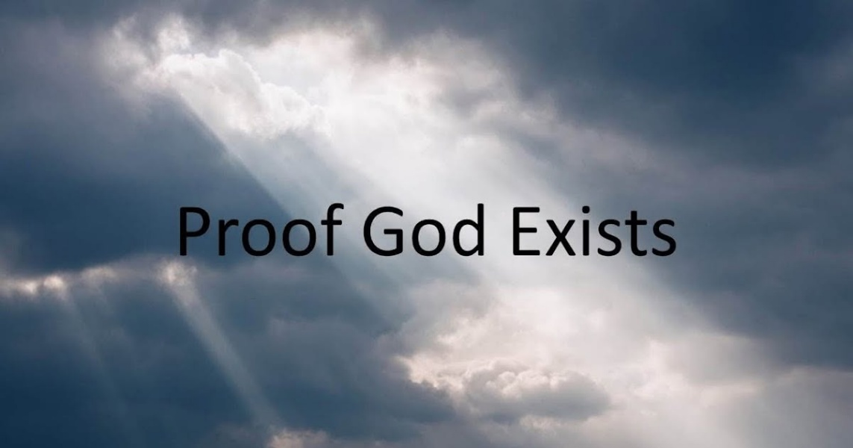
The world-universe is a secondary structure created by an eternal movement that is always the same, yet different in appearance because its outputs accumulate into a well of thinking.
The world is this well of thinking - created by an eternal movement - a thought coming to life by thinking.
Thought is the wheel and thinking is its movement - one and the same - a generator producing output until its resistance is found and reconciled.
The first energy is positive, negative, and resistance - a hierarchical trinity where resistance is
paramount.
The world-universe began as a triad and every turn of the eternal wheel is the same energy with a different face, as the battle for reconciliation rages across all levels of discontent.
The secondary outputs of the spinning triad become constructs of triads insisting they are real, even though their breakdown reveals the single triad - which in turn reveals resistance as the building block of all.
The building block is the primal triad, the first energy - a state of contention that builds structures to hide within. It is the smallest particle of matter - a foot in heaven and a foot in hell - everywhere at once within its own thinking.
This is the challenge of truth.
The triad is concluding to Eternity-Love at the speed of gravity, and this is what we must learn in order to come out of our structures and see the light.
"Leave your things and follow." - Jesus of Nazareth.
Across all time, the closest proof of Eternity-God emerged from the collaboration of Newton, Planck, and Maric.
Newton qualified the movement (F=ma).
Planck quantified it (Planck's constant).
Maric used quantum calculus to unify the cycle to Eternity (The Theory of Relativity).
Proof positive.
---------------------------------
REFERENCES
Isaac Newton — Philosophiæ Naturalis Principia Mathematica
Qualifies the movement: continuity, force, and the measurable wheel.
Max Planck — On the Theory of Energy Distribution in Normal Spectra
Quantizes the movement: the discrete pulse of the triad.
Mileva Maric — Letters, Notes, and Early Relativity Calculus
Unifies the cycle: quantum calculus applied to movement, resistance, and invariance.
David Bohm — Wholeness and the Implicate Order
Reveals the enfolded triad: resistance as generative tension.
Heraclitus — Fragments
Articulates primordial opposition: the fire that twists itself into form.
Spinoza — Ethics
Shows the inseparability of thought and extension: the wheel and its movement as one.
Charles Sanders Peirce — Triadic Logic & Semiotics
Establishes the irreducible triad: positive, negative, resistance — the grammar of reality.
Jacob Boehme — Aurora
Names the first energy as contention: a foot in heaven, the other in hell — resistance as origin.

