THE CENTER TO HOLD
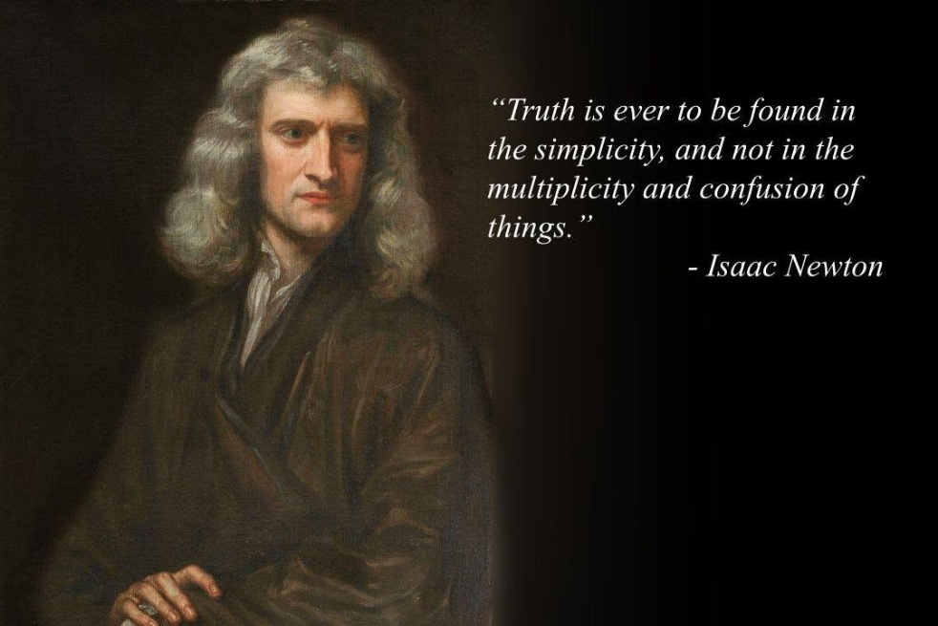
In the quagmire of thinking we have been cast a rope by which to pull ourselves free. The mystics and wise one's of all time, have woven this same rope, but it remains a slippery slope - until now.
We have finally proven that eternity is real.
The world-universe is eternally recurring, and to name it without a means to reach it only deepens the confusion. Isaac Newton described this eternally recurring movement in the simplest of all terms: F=ma. He then invented calculus as the method for tracking its vanishing movement.
Max Planck measured the energy-quotient of this eternal movement. This is Planck's constant - a precise packet of energy formally known as the quantum.
Mileva Maric was the only person in history to unify F=ma through the disciplined application of calculus.
Newton qualified eternal return.
Planck quantified it.
Maric closed the eternal circle - proving that reality exists beyond the illusion of time and space, beyond the illusion of energy-movement.
The table was set but we cannot all follow the proven path. We can, however, recognize Maric's achievement and use it as the door through which we enter the simplicity of F=ma.
Note: The sum of thinking is as a balloon expanding - a unified force that protects its own. As the balloon expands, it resists any individual who seeks to puncture its surface - to deflate the illusion.
All-as-one, we defend against the information that would align us with what is happening behind the scenes: eternal recurrence.
All-as-one, we are the antithesis of One-eternity.
We are eternally recurring - a construct of energy; a spinning wheel generating the means for recovery. This requires learning the construct of a generator - any generator.
Newton, Planck, and Maric proved that reality exists beyond the illusions we insist upon.
One and for all time, we now have a real rope that will not slide away when we reach for it.
"Simplicity is the ultimate sophistication." - Leonarda DaVinci.
-----------------------------------
REFERENCES
Isaac Newton — Philosophiæ Naturalis Principia Mathematica.
Formulation of F = ma and the invention of calculus as a method for tracking continuous movement.
Max Planck — “On the Theory of Energy Distribution in the Normal Spectrum”.
Introduction of Planck’s constant and the quantization of energy.
Mileva Marić — Mathematical correspondence and collaborative derivations.
The only person in history to unify F = ma through disciplined application of calculus.
David Bohm — Wholeness and the Implicate Order.
The hidden generator beneath manifest reality; the implicate order that makes recurrence intelligible.
Roger Penrose — Cycles of Time.
Cyclic cosmology and recurring universes; the dissolution of temporal illusion.
Erwin Schrödinger — What Is Life?.
Continuity of pattern, the persistence of form, and the illusion of death — recurrence expressed biologically.
Friedrich Nietzsche — Thus Spoke Zarathustra.
Doctrine of eternal recurrence and self‑discovery.
Elias Canetti — Crowds and Power.
The collective principal: how the sum‑of‑all thinking selects representatives, deflects truth, and protects its own illusions.

