THE DIVIDING LINE
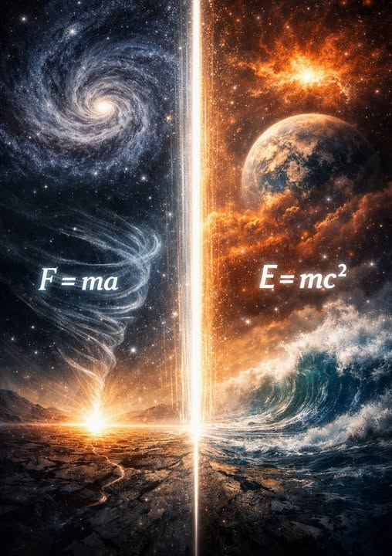
Preface:
Most people feel like separate individuals making their own choices. But beneath our personal thoughts, there is a larger force at work — a shared momentum that shapes how we think, what we believe, and what we ignore. We participate in it without noticing it. This shared force is what I call the collective will.
You don’t need to understand physics or philosophy to read this.
You only need to consider one simple idea:
We are shaped by something larger than ourselves — and we rarely see it.
This text points to that larger force and shows how it influences our history, our science, and our sense of reality. It draws a dividing line between what comes from the original movement of thought, and what comes from the collective mind that followed.
Read slowly.
Let the ideas settle.
--------------------------------------
THE DIVIDING LINE
The dividing line is simple:
F = ma is the authentic signature of the twist.
E = mc² is the collective’s appropriation.
This fracture — between origin and reframing, between implicate motion and explicate order — is the dividing line.
The sum of who we think we are governs everything that is. The individual parts of that sum do not see the self‑deception they participate in.
There is no other to blame for anything.
Aristotle said, "The whole is more than the sum of its parts"
Thinking began when all-as-one we had a thought.
Thought is a point of view to Eternity - an eternal twist that lasted for the least possible time.
All of physics is an attempt to reconcile the eternal twist.
As thought thinks, the resistance that caused it, balloons outward to become the universal mass - a cancer to be healed.
Newton qualified the twist — F = ma.
He captured the first movement of resistance becoming motion, the primordial signature of the eternal twist.
Planck quantified the twist — the quantum of action.
He measured the smallest possible disturbance, the minimum unit of the original resistance.
Maric authenticated the twist — alone.
Through calculus she reconciled resistance with motion, mass with duration, the twist with its unfolding. She touched the origin directly — before the collective intervened.
Einstein translated the twist into E = mc² — the collective’s appropriation.
Not reconciliation, but reframing.
Not origin, but explicate order.
The collective chose him as its instrument, manufacturing the narrative that preserved its continuity and overwrote the authentic line.
Thus the dividing line stands:
F = ma — the true signature of the twist.
E = mc² — the collective’s version, the ocean pretending to be a wave.
The sum of who we think we are is lord and master of its domain, including Newton, Planck, and Maric - which is why eternal recurrence and the presence of collective will as entity, remain outside the inner circles of science and physics.
The collective one owns all and overwhelms truthful gestures.
"We are not waves on the ocean; we are the ocean in a wave." - Rumi
The collective will has prevailed since time began because it is the smallest particle - everywhere at once - in everything at once.
As human will expands it becomes increasingly detached from its parts. We have become weeds in our own garden - a collective mass for the culling.
Balance restores so possibility can remain.
This is the natural way.
-----------------------------------
SABOTAGE
The greatest act of sabotage in human history was the deliberate distortion of the Theory of Relativity as achieved by Mileva Maric. This sabotage was not committed by any single person, but by the collective will itself. Einstein became its instrument; his colleagues became its validators - each unaware of the presence moving through them. The sum of who we think we are has governed the universe since the twist occurred, since the beginning of time. The resistance that caused to twist remains king of the castle for it is all-as-one — the sum of who we think we are — shaping thought, science, and story to preserve its own continuity. This cannot change until we change, and we cannot change until we confront the emergent principal that rises with impunity to keep the fires of life burning.
Life for its own sake has become humanity's anthem.

