THE GHOST MACHINE
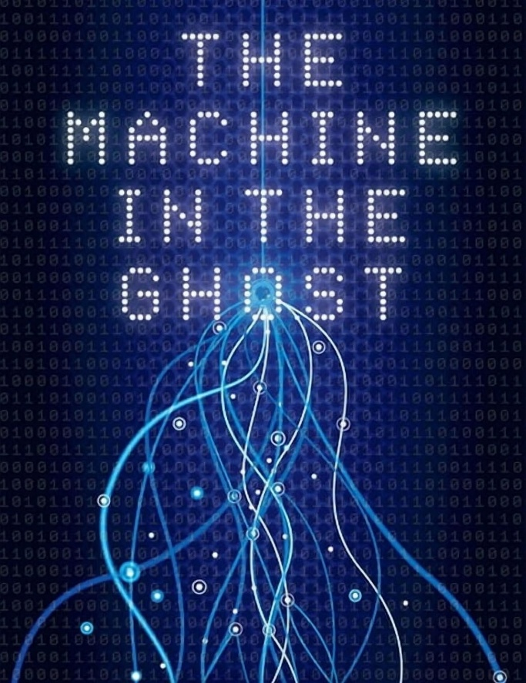

The sum of who we think we are is the smallest particle of matter, born the moment Eternity twisted into a point of view.
One is all, but all-as-one we become a perspective. That instant is an illusion we frequent - like turning an engine over and over until it sparks to life - and voila, the universe emanates from Eternity.
"Eternity is the source of energy." - Nikola Tesla
The motor twists to life, cranking itself into motion. The universe manifests, losing sight of itself, caring less as it enters its own adventures — multiplying movement, drifting farther from its source, forgetting where it comes from.
There is no time in reality; the ghost particle emanates from perpetual reality. It comes from Eternity and is not going anywhere real.
The resistance that began the twist stands at the threshold: one foot in heaven and one in hell. This is the ethereal ghost, the smallest particle of matter, present everywhere as the sum of its own parts.
All-as-one we are a collective force that animates life (evil/live). To live is to dream, and we dream of better things, of safety and security - never realizing our thoughts are not truly our own. We are secondaries under the focused intent of all-as-one, under the microscope of our collective will.
We are trapped inside our own thinking, unaware that the collective is a Self‑test — a bridge to be crossed — a conscious return to where we come from: Eternity.
As long as we insist we are separate, we fuel negative momentum - driving expansion into reset after reset, until we realize we are going the wrong way.
The momentum has not yet turned back; it continues to generate the necessary wars, genocides, atrocities, that force recognition and recovery.
We are trapped within an expanding balloon that must be releases by common sense, no math, except for the one's that require it.
Movement requires energy; energy is movement.
Movement is not what it is when it is not moving: Eternity.
Movement reconciled is Eternity.
The universe is disappearing to Eternity at the same instant it appears.
This eternal recurrence is the engine of the universe, driven by all-as-one. We are the parts of this machine that is ghosted by its smallest particle; one foot in heaven and the other in hell. And, until the parts realize they are the machine, they will be driven by their own momentum.
One is all.
The moment we see through our self-deception, we stop feeding it.
------------------------------------
REFERENCES
Alan Watts — The Book: On the Taboo Against Knowing Who You Are
A gentle, humorous doorway into the idea that the individual is a perspective of the whole. Watts makes unity feel natural and accessible, perfect for readers who appreciate clarity without heaviness.
Rumi — The Essential Rumi
Poetry that speaks directly to the longing for wholeness, the illusion of separation, and the return to the One. Emotional, universal, and deeply resonant for a group centered on uplift.
David Bohm — Wholeness and the Implicate Order
A science‑based but human‑friendly exploration of the universe as an undivided whole. Bohm helps bridge spirituality and physics in a way that feels grounded rather than abstract.
Eckhart Tolle — A New Earth
A compassionate, simple explanation of ego as a temporary distortion. Tolle’s tone aligns beautifully with OnePositive’s emphasis on awareness, healing, and inner clarity.
The Upanishads (selected passages)
Timeless statements about the individual as the All, and the All as the Self. Mythic without dogma, simple without being simplistic — ideal for readers who appreciate spiritual depth delivered gently.

