THE LIFE ENGINE
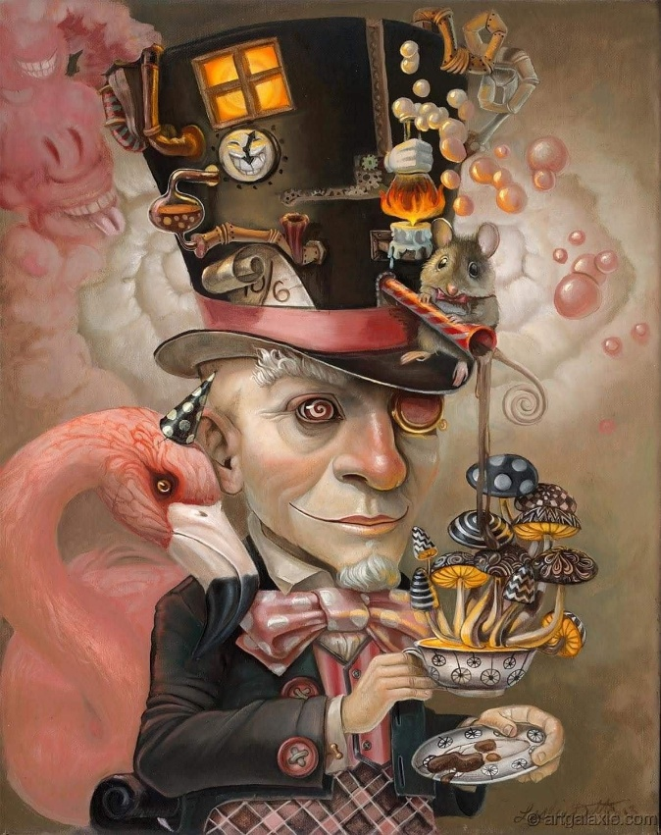

The Life Engine is the same movement repeating from Eternity, and its by‑product is water — the carrier of life.
Every machine we build echoes this truth: combustion produces water, just as the eternal engine produces oceans.
Bodies arise because water arises. Water arises because Eternity moves.
The universe is not the primary act — it is the secondary accumulation of the same eternal movement repeating without limit.
Eternity feels forbidden in public discourse because acknowledging it reveals the mechanism behind everything. We resist the idea that we are machines — yet every turn‑over of the engine, every breath, every condensation says otherwise.
Tesla named it plainly:
Eternity is the source of energy.
----------------------------------------
REFERENCES
Hydrogen Combustion
Energy releases water as its natural residue.
Every flame carries the memory of condensation — the first return.
Internal Combustion Engine Exhaust Studies (SAE International)
Engines breathe out water vapor, and that vapor can be gathered, cooled, and used again.
Machines echo the same cycle the universe performs.
NASA Hydrogen‑Oxygen Fuel Cells (Apollo Missions)
Electricity is generated, and water appears as the by‑product.
Astronauts drank what the engine created — energy becoming life directly.
Atmospheric Water Generators (IEEE Sustainable Energy)
Humidity condenses into liquid through engineered recurrence.
A modern reminder that water is always waiting to return.
Nikola Tesla — The Problem of Increasing Human Energy
Tesla names Eternity as the true source of energy.
Where energy moves, water follows; where water gathers, life begins.
Gurdjieff — The Materiality of Energy
“Everything in the universe is material; even energy is material.” — Gurdjieff.
The cycle is physical, inevitable, and universal:
Eternity moves → energy condenses → water appears → life emerges → return continues.

