THE SACROSANCT TWIST
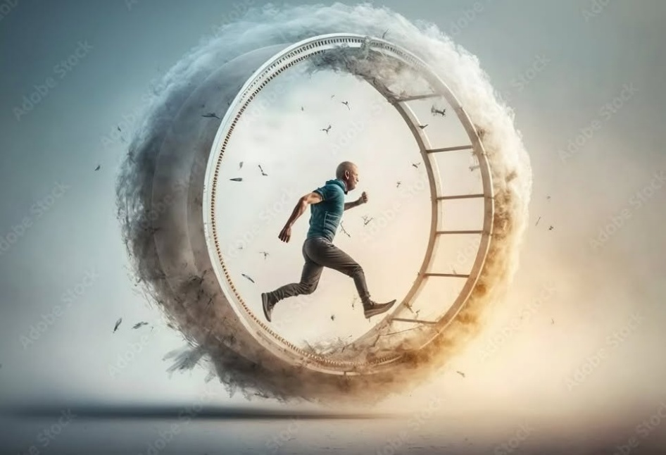

The mechanic of consciousness:
One twists → time appears → the twist repeats → the repetition becomes the universe → the universe is the test we must take.
The only reality is One; all else is illusion.
One twisted to Self‑recognition in an instant of time.
The resistance that caused the twist remains sacrosanct;
it is the primal on/off that generates the universe.
As the twist repeats, it gathers to a collective force with a mind of its own.
Sacrosanct: one foot in heaven, the other in hell.
The resistance that caused the movement remains within its own output everywhere at once — king of the castle.
It is all‑as‑one — antithesis.
We are a mind‑and‑body experience;
the body parts unaware of the mind that animates the universe to ambulate and serve the mind of all‑as‑one.
A spleen does not care to become a heart or a fingernail;
it has its own job to do.
The body parts do not question the system they work for.
The mind of man is the sum of its parts — yet higher because it knows its parts, whereas the parts only know to serve their own points of view.
The sacrosanct twist is primary.
Its body of parts is secondary — a primary and a secondary — a generator producing output.
The mind of humanity cannot solve itself, for it is its own sum.
Resolution may come only when the parts awaken to the knowledge that they are part and parcel — one and the same.
Meanwhile, the sum of parts is a collective force of ignorance with the ability to be everywhere at once.
“The whole is more than the sum of its parts.” — Aristotle
The sum of parts is the empowered over‑lord;
a tenuous event we naturally create to test us back to Self‑recognition.
We are our own test, for without it we would have no hope of reconciling the resistance that initiated the twist.
We are obligated to discover the root of our resistance and begin the process of recovery.
This is what we are here for.
------------------------------------
REFERENCES
Plotinus — The Enneads
The One, emanation, return, and the mechanics of unity and multiplicity.
Advaita Vedanta — Shankara
Non‑duality, the illusion of separation, the Self recognizing itself.
Tao Te Ching — Laozi
The One, polarity, the arising of the ten‑thousand things from a single twist.
The Upanishads
Atman = Brahman, the Self as the whole, consciousness as primary.
Kabbalah — Ein Sof and the Sefirot
The infinite contracting into form; resistance as the engine of creation.

