THE WEAVING
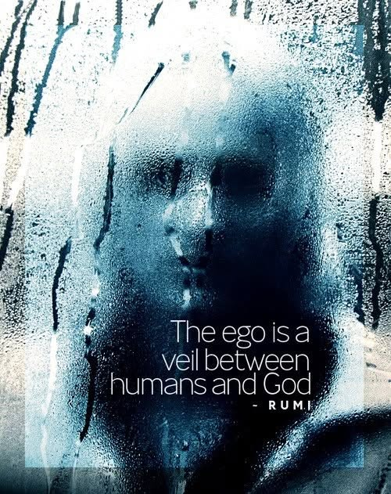

“Life can only be understood backwards; but it must be lived forwards.” — Søren Kierkegaard
Thought is motion.
Motion is the eternal twist.
The twist holds all as one—indivisible, unchanging—no matter how we think about it.
Thinking is the dance of thought.
Thought in action is the sum of its own movement.
“The whole is more than the sum of its parts.” — Aristotle
Thought is everywhere at once, gathering itself through the act of thinking.
We go out to gather back.
But the more we gather, the more we scatter— for the mass of gathering overwhelms the return.
All as one, we become a destructive tide— a consensus that drowns brilliance like waves erase the shore.
The purpose of thought is to gather back. But this cannot begin until we stop overwhelming our most brilliant insights...
Newton saw thought as a particle out of time.
Planck measured its quantum breath.
Tesla gave it form in motion.
Maric used Newton's calculus to unify the quantum to Eternity: Theory of Relativity.
Eternal recurrence is the unfolding of time at the speed of gravity—happening whether we agree or not.
Ignorance floods the field.
Only rational thought can diffuse it.
To rationalize thought is to recognize the resistance that gave it birth.
All as one, we are everywhere at once— resisting the divine prerogative by building monuments to ego.
Planck’s quantum is the smallest movement— the particle of matter, the mind of all as one.
This is a treacherous god.
It is antithesis.
It cannot be woven back until we accept the simplicity of Newton’s particle out of time.
“There is only one electron,” said Wheeler to Feynman. “It only appears many because it moves forward and backward in time.”
-------------------------------
REFERENCES
Heraclitus — Fragments
Newton — Philosophiæ Naturalis Principia Mathematica
Planck — The Origin and Development of the Quantum Theory
Tesla — Experiments with Alternate Currents of High Potential
Mileva Maric — early relativity manuscripts & correspondence (1900–1905)
Nietzsche — The Gay Science; Thus Spoke Zarathustra
Wheeler & Feynman — Interaction with the Absorber as the Mechanism of Radiation
Bohm — Wholeness and the Implicate Order

