DRIVING THE GENERATOR
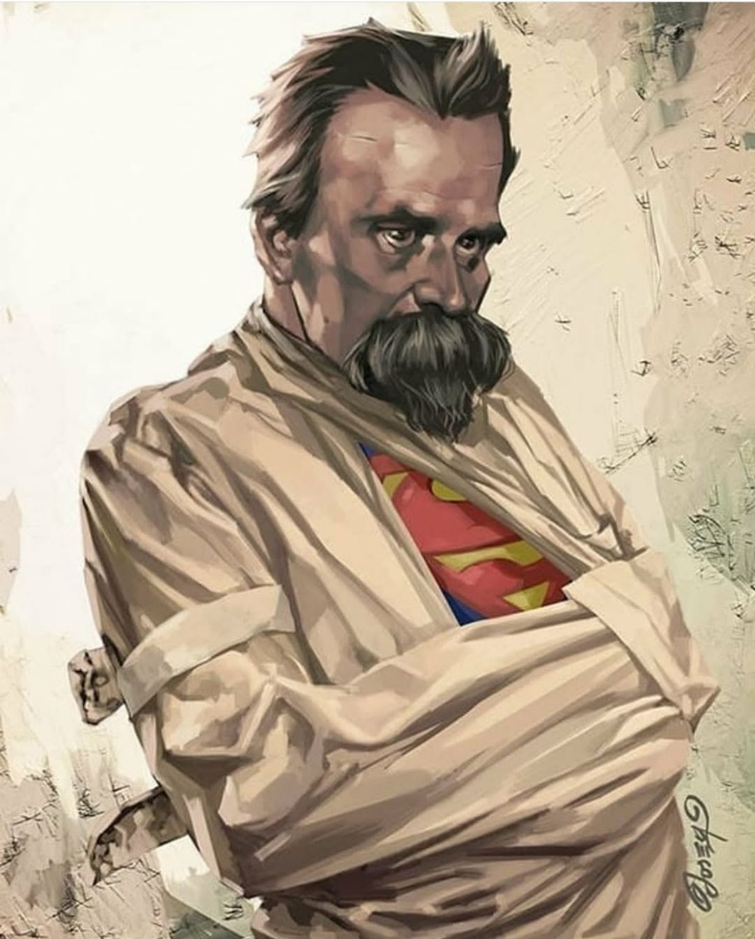

Thought was — and is — the first movement away from God, the first denial, the first twist. Humanity is the gathering force of its own thinking, and thinking is how thought cements its claim in energy.
Every turn of the eternal wheel returns thinking to thought. The secondary always folds back into the primary.
Humanity is the secondary result of the same movement repeating — a generator expressing impressions, impulses, and fear. Yet all is gathered back to the original movement - every cycle, reclaiming what it projected.
Newton revealed the movement.
Planck described its structure.
Marić completed the pattern.
Einstein diverted it.
Each secondary, each relative fragment, is drawn back into thought at every turn of the wheel. Thought runs the entire show with impunity.
Thought is the primal energy — one foot in heaven, one in hell. The secondaries are grounded in positive and negative, an alternating discourse generating the world‑universe. None of the outputs know their ghostly origin.
Thought is everywhere at once within its emerging secondaries. It controls the universe through us, for it is the changing sum of who we think we are, everywhere at once, in command of life’s continuance for its own sake, at any cost.
Thought and thinking are inseparable. But the minions of thought remain unaware that because the universe is energy, there is a positive counterpart — a positive wing awaiting recognition. Until we recognize this wing, we are doomed to fly in circles.
This is the metaphor that describes the difference between Newton’s F = ma and Einstein’s E = mc² — disappearance into Eternity or continued containment.
The collective will of humanity keeps this contradiction under lock and key. No school teaches the deliberate tangent from truth that diverted eternal focus into the cycles of fear - the same fear that culminated in Hiroshima and Nagasaki.
That destruction marked the beginning of the nuclear era of fear and ignorance - continued destruction, unless we discover that we — all‑as‑one — are the psycho‑emotional driver of the universal generator.
We are hell-bound unless we awaken to what is happening anyway:
ETERNAL RECURRENCE is the wheel of life spinning, and we, all-as-one are its driver. There is no other.
---------------------------------------
EPILOGUE
COMMENT WITH IMAGE (Nietzsche)
The mind that shattered the old gods now wears the uniform of containment. Beneath the bindings, the generator hums — the primal energy of thought refusing extinction. The Superman is not a savior but a reminder: even in restraint, the eternal wheel turns. And in that turning, he waits — not to rescue us, but to answer our call to action.

