Eternal Recurrence …A Step out of Time
FREE DOWNLOAD:
http://www.onepositive.com/.../Eternal-Recurrence-A-Step...
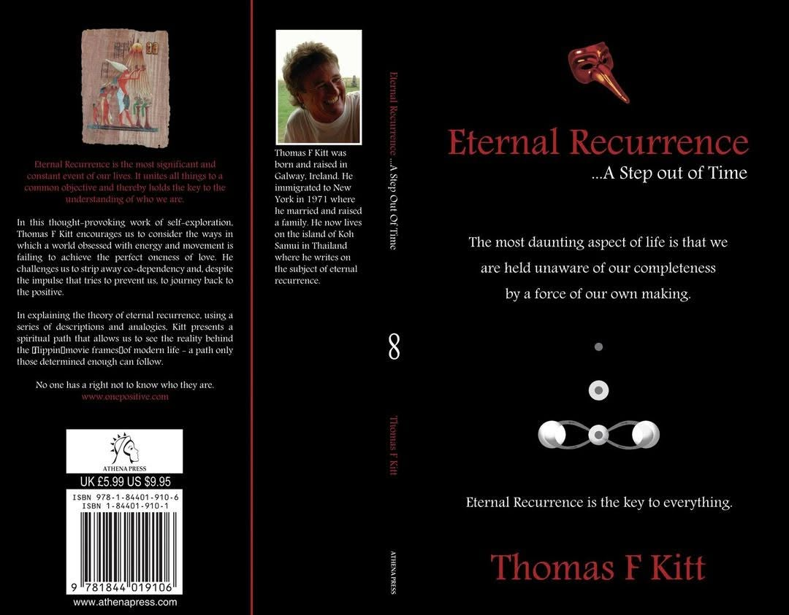

THE $500 SIGNAL
I published Eternal Recurrence in 2007 for ten dollars. Years later, without hype, demand, or attention, it quietly climbed to five hundred. That jump wasn’t success — it was resistance.
When a truth threatens the collective’s story, the collective doesn’t censor it. It simply withdraws awareness until scarcity does the work.
A $10 book becoming a $500 artifact is the collective will saying:
“Keep this out of reach.”
That was the first time I saw the collective will in action.

