ETERNAL RHYTHM
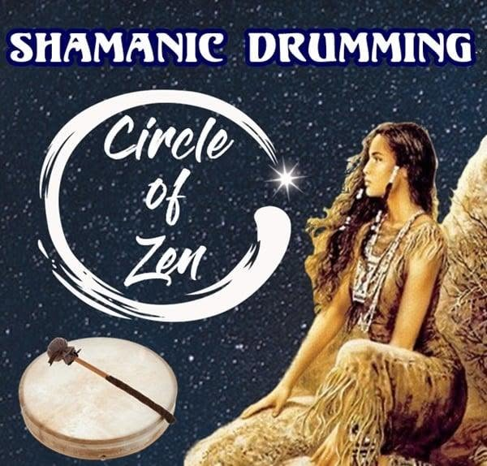

The universe is energy, and energy is movement:
ALL IS ILLUSION.
The energy of illusion is an interactive mechanism, and once the mechanism is seen, its driver is revealed as one's own self. We stop pointing at the moon and instead become the moon.
In rhythmic environments many engage the transition to eternal Love, if but for a short while.
Universal energy began when all, as one, we disturbed the equanimity of Eternity, and an 'alive' spark appeared. That spark repeats, and keeps repeating, building the fires of life that form the universe.
One spark at a time the universe comes to life.
Humanity’s task is to see the spark within the fire and come home to Love simply by recognizing that it is happening anyway.
Eternal Recurrence is the rhythm beneath all things.
.............................................................
REFERENCES
Advaita Vedānta — Māyā as cosmic illusion; the Self as the underlying driver.
Gurdjieff, Beelzebub’s Tales — Humanity asleep inside a repeating cosmic mechanism; awakening reveals the inner spark.
Heraclitus, Fragments — The ever‑living fire as the rhythmic principle of reality.
Nietzsche, Thus Spoke Zarathustra — Eternal Recurrence as the fundamental rhythm beneath existence.
Whitehead, Process and Reality — Reality as repeating events rather than static substances.
Bohm, Wholeness and the Implicate Order — The universe as unfolding movement; separateness as illusion.
Wheeler, “Law Without Law” — Creation emerging from a disturbance in equilibrium; the participatory spark.
Meister Eckhart — The soul’s return to Love as the natural movement of creation.
.
.
.
.
Picture: Where rhythm becomes meditation — the drumbeat of the universe calling us home.

