A declaration for those who refuse the prisons of time — a reminder that awareness is the only force that carries us through illusion, through repetition, and through the fires of hell.
FIRE AGAINST FIRE
A Manifesto
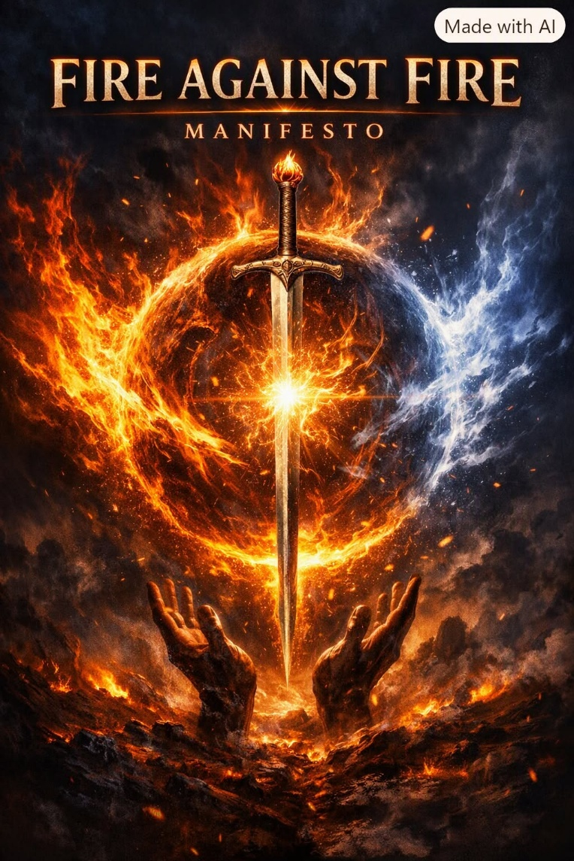

This manifesto is a declaration, not a discussion. It speaks to the hidden architecture of energy, the prisons of time, and the work of the aware ones who stand against the collective force of ignorance. It is offered as a sword — to cut through illusion, to confront repetition, and to remind us that reconciliation is possible only through awareness. Read it as fire meeting fire.
Universal energy has a common center — an emergent principal that rises with impunity to command all that it is. It steals our power and repays us with time.
The universe is energy.
Energy is movement.
Movement is illusion.
In the beginning, a spark appeared — and continues to appear as repetition turns to fire.
The fire is a non‑linear accumulation of sparks - each one an alternating opposite: positive and negative, the primal vibration of existence.
Resistance is the hidden cause of movement.
The resistance that precedes all things is the smallest particle — the alive center of everything — an emergent principal orchestrating its life through us. We are its subordinates, serving life sentences. It lives only as long as we fuel its fire.
We are serving time for the sum of who we think we are.
All-as-one we kill to live - an Ouroborus eating itself alive.
The collective force protects the secret of the spark — the spark that is disappearing to nothing. The collective will stop at nothing to preserve its life in energy. Awareness places me in its firing line, and I offer its attacks as sacrifices on the altar of One.
This is a choice for grace in the face of ignorance - a choice made by many who keep alive the possibility of reconciliation through time. Without these aware ones, the candle of life has a short wick.
We are repetition of the same eternal movement: a twisted thought, a vibrating positive and negative whose cause is everywhere at once - a ghost to behold.
Death releases us from the prisons of time - into unconditional Love - into the inevitable awareness that work remains. And so, we return by our own choice, never in the same form, but always in perfect form.
Perfect, perfect, always perfect.
We order pain to show the way.
Perfect, perfect, always perfect.
"God does not play dice with the universe."
Humanity must gain positive traction against the collective force of ignorance.
The cohesive work of Newton, Planck, Tesla, and Maric, has given us the means by which we may see through this force:
Newton qualified the movement: F = ma.
Planck quantified the spark: 6.62607015×10⁻³⁴ J·Hz⁻¹.
Marić completed the eternal circle through calculus.
Tesla harnessed the alternating cycle to power the world.
When we learn the practical structure of energy as circumscribed, we will leave our prisons in time and fight fire with fire.
Jesus said: “I come with a sword.”
-------------------------------------
A Simple Analysis:
We are Love on Fire.
We enter the fire to be consumed and resumed until Love is revealed. This is the true meaning of falling in Love.

