INTRO — The first energy was a twisted thought, and the universe is the thinking of that thought. The sum of thinking becomes an emergent principal — a natural catalyst that drives recovery, return, and remembrance. This happens when pain gives no option but to change direction; rarely do we learn it on our own.
THE EMERGENT TWIST
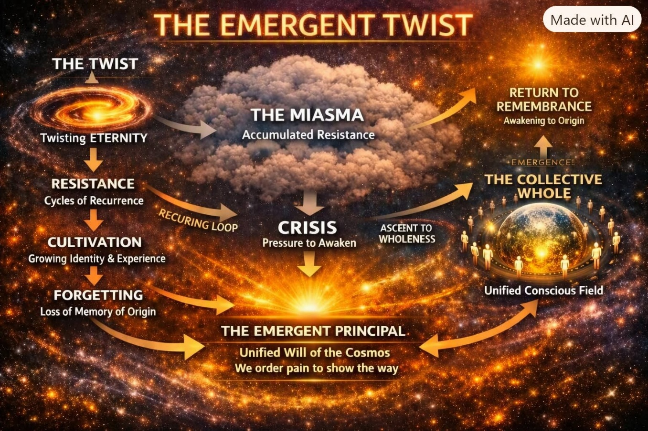

We twisted Eternity and returned - as a twist must.
But the resistance that caused the twist remained, and so, we are thermodynamically obligated to repeat until resistance is shed.
As the twist repeats it cultivates resistance - like crops to harvest.
We grow to gather back, but the crops forget as they become enthralled by their own existence.
The twist endures and feeds the expanding miasma, hoping for a return to the memory of origin.
Resistance is naturally disposed to react to the pain that follows it. This is catalytic.
Individually, we reap our own harvest according to who we think we are, unaware that the sum of parts forms a collective whole that protects its parts as if its life depends upon it - because it does.
“The whole is more than the sum of its parts." - Aristotle
The emergent Principal is everywhere at once and we must learn how this can be so. We must educate our thinking, but first recognize the collective experience of all-as-one - how, unbeknownst, we orchestrate the universe to maintain our points of view. .
We are what we think.
We think what we know.
We know what we learn.
The collective will is everywhere at once as the sum of our own thinking - a beast of free rein until we call it back. Meanwhile, in a nutshell, the framework is a twisted thought thinking into twisted alleyways, searching for the thermodynamic principal we ourselves created. This is the challenge.
"Simplicity is the ultimate sophistication." - Leonardo Da Vinci.
------------------------------------
REFERENCES
Carl Jung — Collective unconscious, archetypes, and the shared field of human thought.
John Archibald Wheeler — The “one‑electron universe”; the idea that a single particle traces every possible path through spacetime, appearing everywhere at once — a perfect analogue for the Emergent Principal.
David Bohm — Wholeness and the Implicate Order; the universe as an undivided flowing whole.
Plotinus — The Enneads; the One, emanation, return, and the forgetting of origin.
Erwin Schrödinger — What Is Life?; entropy, order, and the thermodynamic obligations of living systems.
Geoffrey West — Scale; emergent behavior in complex systems and how wholes protect their parts.
John Holland — Emergence; simple rules generating complex collective behavior.
G. I. Gurdjieff — Self‑remembering, mechanical life, and awakening from the trance of identity.
Ilya Prigogine — Dissipative structures and irreversible processes; systems don’t just endure resistance — they grow because of it.
Roger Penrose — Twistor theory, gravitational collapse, and non‑computable consciousness; the deep geometry of recurrence and return.
.
.
.
.
PICTURE: A visual map of the Twist — how resistance grows, how forgetting spreads, and how emergence calls us back to origin.

