SIMULATION: Breaking the Mold
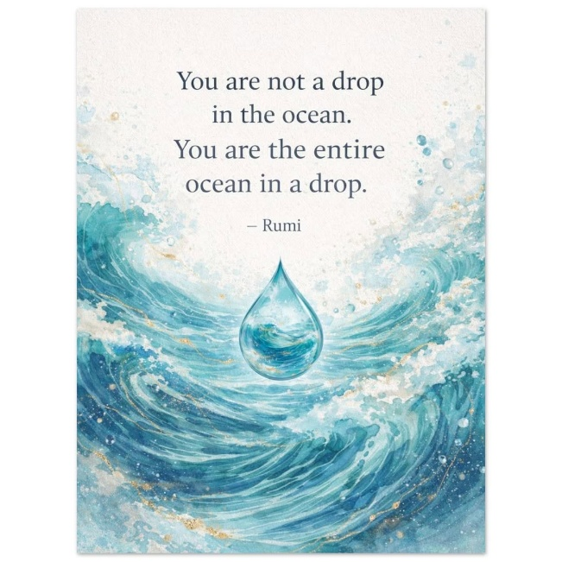
Energy is a trinity: positive, negative, and resistance.
The resistance is All-as-One:
Eternity turned inside out for the moment it took resistance to gain its wings.
Once in flight, the resistance grows, becoming a body for the wings to support.
The wings react in service to the body.
All-as-One, we are the resistance that twisted Eternity for a moment in time, recurring to become the world and the universe.
The universe is generated by the same wheel turning.
The bird in flight is the sum of its experiences in every recurring moment, and we, the workhorses, are unaware that the primal resistance is the beginning and the end of everything in the same instant.
Nothing Matters
Isaac Newton qualified the trinity disappearing into Eternity.
Max Planck quantified the movement.
Mileva Marić used the information to build a logical pathway from time to Eternity.
The Trinity Conspiracy
The animated resistance is everywhere at once, directing its parts through its collective experience to serve the will of the collective, no matter the cost.
Everyone serves the collective, and the coming and going of parts is semantic.
What matters is that the bird in flight continues.
All who see through the manipulation are washed back into the fold to be assimilated, like waves upon the ocean.
This is the challenge of every individual.
"The whole is greater than the sum of its parts." - Aristotle
All-as-One, we are an emergent Principal, everywhere at once as the primal rhythm.
The primal rhythm is the first energy, and we are its algorithms.
No one has ever broken the mold of the universe.
The simulation persists because the parts mistake themselves for the whole.
The moment a part remembers its origin, the illusion weakens.
Not because the universe changes, but because the observer does.
The bird cannot be stopped, yet it can become aware of its own flight.
To awaken is not to escape the wheel.
To awaken is to become conscious of the hand that turns it.
We are obliged to wake up from this simulation.
This is why we are here.
----------------------------------
REFERENCES
Aristotle - Emergence and the principle that the whole exceeds the sum of its parts.
Isaac Newton - Universal order, motion, and gravitation.
Max Planck - Quantization of energy and the foundations of quantum theory.
Nikola Tesla - Resonance, vibration, and electromagnetic systems.
Mileva Marić - Mathematical reasoning at the dawn of relativity and modern physics.
G. I. Gurdjieff - Self-remembering, awakening, and escape from mechanical consciousness.

