THE ENGINE OF ILLUSION
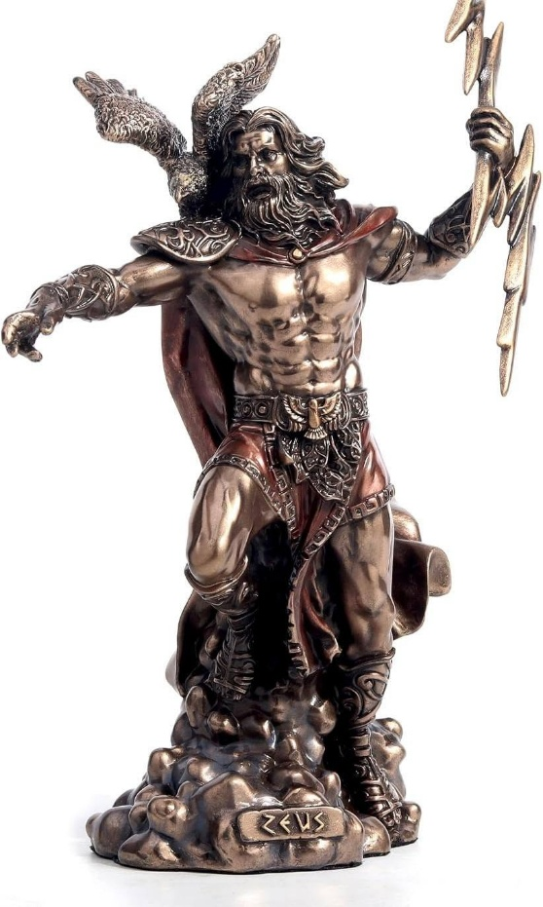

The universe is the body of one thought — not metaphor, but mechanics. All existence is the collective thinking of Thought itself: the mind‑field of the universal body.
Thought is an energy triad:
positive — negative — resistance.
As thought thinks, it generates scaffolding of triads to support the illusion of its own existence.
Thought is an energy twist - an outsider - the watcher and the watched - positive and negative.
This primal trinity is the building block of the scaffolding we are obliged to dismantle back to One.
All come from One.
“Eternity is the source of energy.” — Nikola Tesla.
Life is the testing ground for returning to the unconditional state of Love/One.
We maintain the scaffolding to protect our personal delusions.
We live inside the structures we create, without knowing that we are reciprocals.
The scaffolding protects us from recognition — and protects recognition from us.
There is no time in reality, and within illusion, all is possible.
Time is the medium of resistance — an illusion.
Only Eternity is real - everything else is resistance.
Time and energy are synonymous: the outward expression of thought resisting its origin.
The hierarchy of thought — the triads, the scaffolding, the expansion — is the testing ground for our return to reality.
The sum of our thinking is the god we manufacture — and worship by default. This neon god is the sum of who we think we are, it is all-as-one.
“You said in your heart, ‘I will ascend to the heavens; I will raise my throne above the stars of God…” — Isaiah 14:13.
Every living thing is scrambling to become its own god. Despite knowing, deep down, they have been trapped by their own structural devices.
The energy hierarchy persists, no one knowing how to be, everyone longs to be free.
The energy hierarchy is self-forming, to test us out of illusion and into reality.
Meanwhile we labor under the collective unconscious, oblivious to the balancing wars, genocides, and atrocities that keep us on the dance-floor.
We are constantly recycling into the same spark that ignites the universe — feeding the fire of life — feeding the god we made.
Woohah.
---------------------------------
📚 REFERENCES
The Upanishads — One becoming many; consciousness as the only substance.
Laozi — Tao Te Ching — Polarity, resistance, return; the twist rendered as flow.
Plotinus — The Enneads — The One emanating into multiplicity; the divine inversion.
David Bohm — Wholeness and the Implicate Order — Physics as metaphysics; reality as unfolding thought.
Whitehead — Process and Reality — Reality as event; scaffolding as perpetual becoming.
Nikola Tesla — Writings & Lectures — Energy as Eternity; motion as illusion.
Hofstadter — Gödel, Escher, Bach — Self-reference loops; triads upon triads.
Donald Hoffman — The Case Against Reality — Perception as interface; illusion as function.
Meister Eckhart — Recognition as collapse of separation.
The Bhagavad Gita — Duty within illusion; action without identity. ------------------------------
🔻 ENDCAP
To know that the universe is disappearing and reappearing at the speed of gravity is the key that opens the door for the work to be done.
It is happening anyway.
Recognition is the collapse of resistance into its origin.
.
.
.
.
Zeus — The lightning‑bearer stands at the fulcrum of illusion, mistaking his own charge for sovereignty. Mistaking its Self.

