THE GHOST OF RESISTANCE
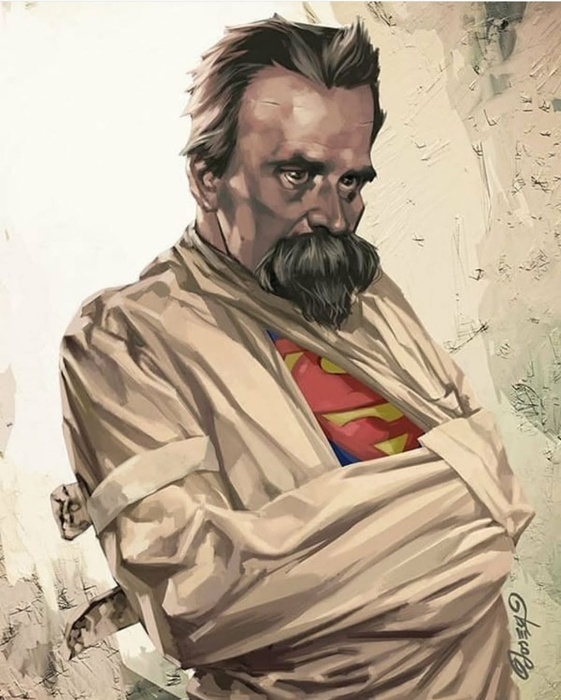

Thought was — and is — the first movement away from equanimity, away from Eternity, away from God.
In the primal twist, thought — all‑as‑one — bent equanimity into a point of view. Everything that follows is twisted thinking: thought attempting to reconcile its own transgression.
Humanity is the unified force of its own thinking returning to thought at the speed of gravity. This is the work of Newton, Planck, Maric, and Tesla in a nutshell: the physics of the eternal twist.
Every release of the twist is a turn of the wheel — folding back into thought. Thought and its thinking are one and the same, evoking an energetic hierarchy that allows its smallest particle to be everywhere at once — leader of the pack.
Thought is the ghostly resistance that created the positive/negative whose repetition emanates the universe to serve its purpose: life for its own sake.
The resistance that caused movement stands high above the gyrations of energy — everywhere at once — in your head.
“The whole is more than the sum of its parts.” — Aristotle
The pinnacle of energy has one foot in Eternity, the other in energy.
It is half‑dead and half‑alive. It is the primal resistance of all‑as‑one: the twisted thinking of thought creating its own impressions, simply by repeating itself.
All is gathering back to the original movement. This is the structural dynamic to be understood.
Newton revealed the movement.
Planck quantified the energy of primary inertia: the ghost.
Marić used Newtonian calculus to illustrate F = ma.
Tesla used the alternating wheel to power the Industrial Revolution.
Each secondary emanation, each relative fragment, is drawn back into thought at every turn of the wheel. Thought runs the entire show with impunity.
Thought is the primal energy — one foot in heaven, one in hell. All secondaries are grounded in positive and negative, an alternating discourse generating the world‑universe. None of the outputs know their ghostly origin.
Thought is everywhere at once within its emerging secondaries.
It controls the universe through us, for it is the changing sum of who we think we are — everywhere at once — in command of life’s continuance for its own sake, at any cost.
Thought is the sum of who we think we are. We are one and the same. We, as one, are the responsible party.
Thought and thinking are inseparable. The minions of thought remain unaware that because the universe is energy, there is a positive counterpart within all that happens — a positive wing awaiting recognition.
Lost outside ourselves, we fly in circles until we acknowledge it.
This is the metaphor that describes the difference between Newton’s F = ma and Einstein’s E = mc² — disappearance into Eternity or continued containment.
The collective will of humanity keeps this anomaly under lock and key. No school teaches the deliberate tangent from truth that diverted eternal focus into the cycles of fear — the same fear that culminated in Hiroshima and Nagasaki.
That destruction marked the beginning of this nuclear age of fear and ignorance. The destruction will continue until we discover that we — all‑as‑one — are the psycho‑emotional driver of the universal generator — a mass of ignorance following its collective will.
We are hell‑bound unless we awaken to what is happening anyway:
ETERNAL RECURRENCE: the wheel of life hums beneath the formulations of thought.
We, all‑as‑one, are its driver.
There is no other.
---------------------------------------
EPILOGUE
COMMENT WITH IMAGE (Nietzsche)
The mind that shattered the old gods now wears the uniform of containment. Beneath the bindings, the generator hums — the primal energy of thought refusing extinction. The Superman is not a savior but a reminder: even in restraint, the eternal power of God awaits our call to action. All-as-one we imprison our own thinking to maintain the collective will.

