THE NEGATIVE WING
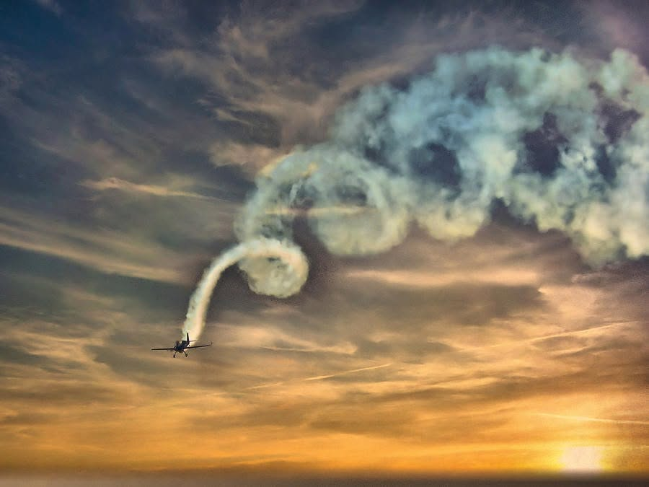

The tiniest particle of matter is not a particle at all, for nothing in the universe is still. The universe is energy, energy is movement, and movement is illusion — therefore the smallest particle is an illusion of movement repeating itself.
Movement began when all‑as‑one we twisted the eternal One —
a brief deviation, a momentary escape, a departure that endured only until its own rising tension untwisted it.
That first distortion became the primordial recurrence: the particle disappearing and reappearing until the resistance that birthed it is reconciled.
This particle is triune — positive, negative, and resistance —
inseparable aspects of the same original transgression.
All‑as‑one we resisted Eternity and found ourselves trapped like hamsters on a wheel, circling endlessly, generating resistance to solve resistance, chasing our own tails.
As the universe expands, its growing tension overwhelms the memory of the disappearing particle.
This is the work before us.
----------------------------------
Thesis
The escape from freedom was reeled back by its own tension and continues to repeat until the resistance that caused it is resolved.
The tiniest particle resonates for this purpose, generating the means for work to be done — creating tension to solve tension —
a mad cycle losing its memory.
Humanity is lost within its own accumulation, unable to remember its purpose for being, answering only to its collective opinion
of what life is meant to be.
We are moving in the wrong direction insisting on continuance despite the state of the world — despite the fact that we are flying in a circle, a death spiral unless we remember the particle.
The eternally recurring positive and negative inundated the medium: alternating opposites spiraling downward,
while the positive wing whispers:
fly straight — I will take you home if you but recognize that I am here.
Humanity is obsessed with its own possibilities — flying on one wing, unaware of the regenerating particle that hums beneath every scene.
Eternal recurrence continues; few learn of their own accord because the collective thought of humanity governs each of its parts.
The universe is disappearing into the tiniest particle and on to Eternity — repeating until the primordial resistance is reconciled.
Each return crashes at the gate of heaven until the work of resolving our transgression is achieved.
When the positive and negative wings are in accord, the flight to Eternity is balanced to approach the divine prerogative.
From negative extremes we come to center and feel Love drawing us home.
-----------------------------------
REFERENCES
Erich Fromm — Escape from Freedom (1941)
Humanity flees freedom, circles under tension, and must consciously return.
Isaac Newton — Principia Mathematica (1687)
The primal illusion of the particle disappearing out of time at the speed of gravity.
Max Planck — “On the Theory of the Energy Distribution Law of the Normal Spectrum” (1900)
Birth of the quantum; the particle as a unit of tension.
Friedrich Nietzsche — Thus Spoke Zarathustra (1883–85)
The modern articulation of eternal recurrence.
Mileva Marić
Used Newtonian calculus to bridge recurrence to Eternity — the true Theory of Relativity.
Nikola Tesla — Alternating Current & the Resolution of Polarity (1888)
Demonstrated that energy is oscillatory, not linear; AC works because it emulates what is happening anyway: Eternal Recurrence, ad infinitum as long as resistance remains. “Eternity is the source of energy.”
----------------------------------
Core Takaway
The Negative Wing is the story of resistance losing its memory — the particle repeating its transgression until the positive complement is consciously engaged.
Memory returns.

