THE ONE THAT FLIES STRAIGHT
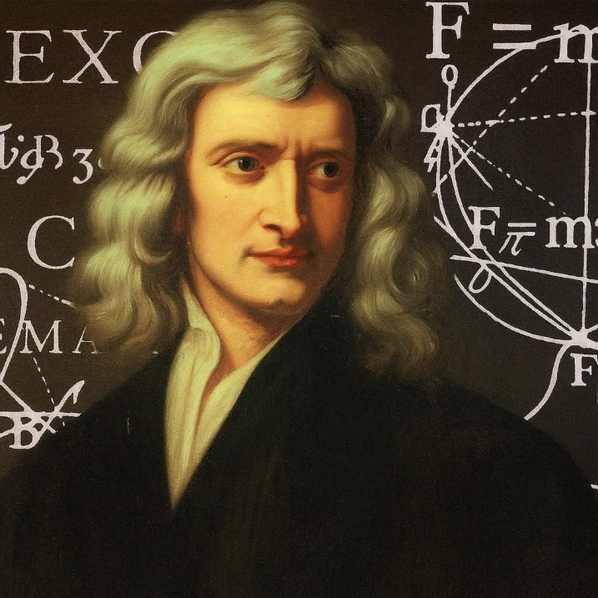

We are a conspiracy against ourselves.
The sum of us, the sum of energy, is a being like any other, except it is the smallest particle of energy with the power to be everywhere at once, existing as the constantly changing sum of our own thinking and exacting its will according to how we, collectively, dictate it.
The being rises high above the sum of its parts and does not know the collective master it serves. It thinks like you and I, and defends its life, just as we do.
It emerges within every detail to defend its fragile life of empowerment
This is why humanity still fails to explain the Theory of Relativity as a single particle of matter recurring through Eternity at the speed of gravity.
The sum of who we think we are is smart as hell and has the collective advantage of overwhelming those who think outside the box.
The breakthroughs by Newton, Planck, Maric, and Tesla, have been plundered by the collective will of humanity under the leadership of a gross ignorance that is everywhere at once.
If you, and I mean YOU, do not know the concept of F=ma, you are part of the demon horde that savages others in order to maintain life as we see fit to live it.
In our ignorance, we destroyed Hiroshima and Nagasaki, what next?
Even at this late stage, you can find the courage to enquire into F=ma, the simplest equation ever formulated and one that holds the answer to everything.
Let your enquiry begin at the beginning.
The recurring particle of energy has three parts: positive, negative, and resistance.
The negative seeks itself through enquiry, unknowing that the sum of enquiry is a changing opinion that leads the way.
The positive is sacrosanct. It never moves, yet is everywhere at once as the answering counter to every move we make.
"Perfect, perfect, always perfect."
This is the one that flies straight.
This is what Newton meant by F=ma.
---------------------------------------
REFERENCES
Socrates
Heraclitus
Newton
Tesla
Planck
Gurdjieff
Jung
Teilhard de Chardin
"I think, therefore I am." - René Descartes

