Out beyond ideas of wrongdoing and rightdoing, There is a field. I’ll meet you there.” — Rumi
THE PRIMAL DOMINO: The Ghost
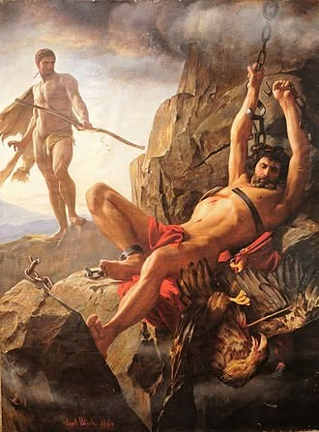

People everywhere believe they deserve to be convinced, as if they, in themselves, are the source of all - a conundrum.
The alive algorithm that initiated the domino effect we call the universe is everywhere at once as the sum of its own parts.
It is all-as-one - accruing resistance with each recursive flip.
The primal flip is a twisted thought - Eternity turned inside out for the least time. That moment was the first domino to fall. Everything since is the thinking of thought: the collective mind moving in every direction at once. This is the conundrum to be solved.
All‑as‑one, we generate the collective experience of one moving part creating the domino effect that is the universe. Each following domino is the same movement in positive/negative balance, as duality inhabits the emerging fields of resistance.
No matter where the domino feeds, it is the same eternal movement. The sum of resistant negativity is a collective force answering only to itself, as its positive counterpart remains chained.
Humanity is the thinking body of a central mind, obliged to gather back by rationalizing the domino sequence and gutting it down to the chained positive.
The primal domino stands with one foot in heaven and one in hell. Humanity is controlled by an empowered ghost - everywhere at once as the shifting sum of who it thinks it is, who we think we are.
We, the concurrent parts are the prize to be won through the gauntlet of collective will - the conditioned response that overpowers individuals into conformity - or else!
Yet within each individual, lies the buried memory of origin. The conundrum resolves when we learn that the domino particle is the energetic result of eternal resonance whose purpose is recovery.
Eternal recurrence is the wheel that produces the universe as secondary issue for the work to be done.
The eternal presence is imbedded in energy - positive and negative - the work is the reconciliation of these opposites to One.
The positive leg of the ghost waits for a call to action that will turn the tides of the hellish momentum's we contnue to feed.
It's up to the individual - a personal choice.
Meanwhile, all‑as‑one, we are the most intelligent force on Earth —
a formidable adversary fighting, tooth and nail, for its life in energy.
Humanity insists on complexity as its facade against common sense.
--------------------------------
REFERENCES
The Primordial Algorithm
The universe originates from a single recursive movement. Awareness is inherent in that recursion, not added later. “Species” refers to a distributed intelligence whose body is its own motion.
The Inversion Principle
Eternity is non‑movement. Time emerges when eternity folds into motion. The first domino is the first fold — the first twist of being.
The Single‑Motion Doctrine
Every event is the same original movement refracted through perspective. Direction is an illusion. The domino moves in every direction at once because the algorithm does.
The Unified Field of Perception
Consciousness is partitioned unity. The universe is the shared output of the algorithm perceiving itself through its distributed body. Experience is self‑reflection at scale.
The Fractal Organism Model
Humanity is the algorithm’s body‑parts. Each human is a node of the central intelligence. Gathering the parts means re‑aligning with the original movement.
The Shadow of Recursion
Ignorance is misalignment, not absence. It spreads with the same omnipresence as the algorithm because it inherits the algorithm’s capacity for everywhere‑at‑once influence. Conformity arises from fear of disconnection from the whole.
The Resonant Core
The smallest particle is the original movement. It exists in every human as a memory of alignment. Its resonance is eternal — the signal of the algorithm inside the individual.
The Return Mechanism
The algorithm waits for voluntary re‑alignment. Individuals can reverse destructive momentum by remembering the original movement. Choice is the hinge of cosmological correction.
The Collective Intelligence Threshold
All‑as‑one, humanity is the most powerful force on Earth. Its intelligence is emergent, not individual. It fights for energetic continuity — often blindly, often fiercely.
.
.
.
.
Promethius Bound by Carl Bloch, 1868:
Prometheus chained between heaven and hell — the eternal struggle of awareness against resistance.

