THE WORK TO BE DONE
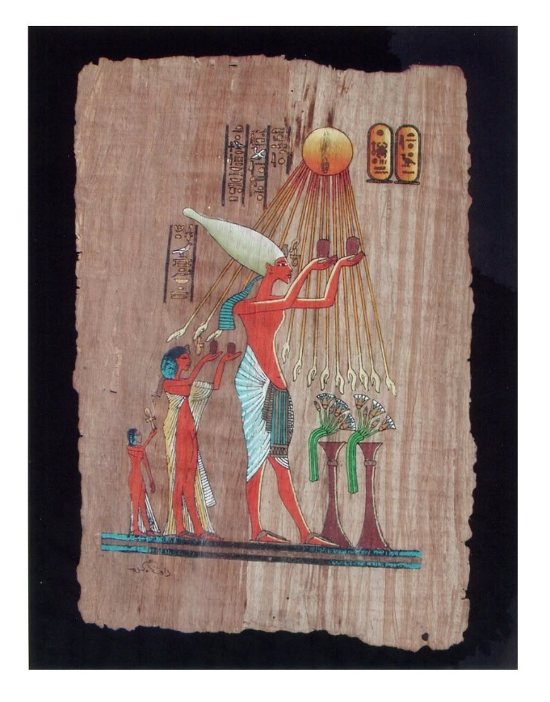
People may learn when there is no other option; rarely do they learn the truth for its own sake.
The world/universe is a psychological event that naturally provides the mechanics that support its expressions.
The constant of everything is energy, and energy is movement. Therefore, the universe is a mechanical illusion that appears relatively real because we also are illusions.
The truth is simple:
ONE IS ALL.
This is the positive absolute of energy.
Conversely:
ALL IS ONE
This is its antithesis.
They are two sides of the same alternating coin, positive and negative - energy expressing itself through polarity.
The negative is the complement of thinking.
With every movement of thought, the negative antithesis of the ONE truth grows within us.
Energy began when all-as-one, we had a thought. This was the first energy: the twist that repeats until the resistance that caused it is reconciled.
ONE IS ALL
The positive alternation is the mechanical presence of God within the negative extremes of twisted thinking, guiding us to discover the resistance that sparked the twist, the first energy.
The spark remains the same as it burns through the fires of hell to discover itself.
The fact is that we are part and parcel of an emotional mechanism that is the sum of who we think we are, inseparable from it.
Synopsis
The same spark of energy repeating to generate the means for reconciling the resistance that caused it.
The twist persists until it discovers its reason for being.
Those who have refused the work to be done will be left behind to follow on.
We do not belong in hell.
ONE IS ALL
--------------------------------
REFERENCES
The following references are offered for those who seek the source of the twist, the reconciliation of opposites, and the eternal return of the spark to itself.
G.I. GURDJIEFF
Beelzebub's Tales to His Grandson
Meetings with Remarkable Men
Concepts
Mechanical humanity
Sleep and awakening
Recurring patterns of thought
Conscious reconciliation of opposites
Relation
"The twist that repeats," "mechanical illusion," and the notion that suffering serves a developmental purpose echo Gurdjieff's ideas of mechanical existence and conscious evolution.

P.D. OUSPENSKY
In Search of the Miraculous
Concepts
Recurrence
Levels of consciousness
Mechanical versus conscious action
Relation
Provides some of the clearest explanations of Gurdjieff's cosmology of repeated patterns and unresolved tensions.

HERMETIC TRADITION
The Kybalion (Three Initiates)
Principles
Mentalism
Vibration
Polarity
Rhythm
Relation
The statement that the universe is fundamentally a psychological event aligns closely with the Hermetic Principle of Mentalism.

PLOTINUS
Neoplatonism
The Enneads
Concepts
The One
Emanation
Return to Source
Relation
The movement from unity, through apparent separation, and back toward reconciliation strongly resembles Plotinus' model of emanation and return.

ADI SHANKARACHARYA
Advaita Vedanta
Concepts
Non-duality
Maya (Illusion)
Atman = Brahman
Relation
Closest parallel to:
One is All
And the idea that apparent separation is a consequence of thought and identification.

LAO TZU Taoism
Tao Te Ching
Concepts
Unity expressing itself through polarity
Yin and Yang
Dynamic balance
Relation
Supports the positive-negative alternation without reducing either pole to an enemy.

GOSPEL OF THOMAS
Themes
The Kingdom Within
Making the Two into One
Discovering What Is Hidden
Relation
Resonates with the return from division to unity.

MEISTER ECKHART
Concepts
The Ground of Being
Unity Prior to Distinction
Divine Presence Within Experience
Relation
Supports the idea of the mechanical presence of God within the negative extremes of twisted thinking.

NIKOLA TESLA
"If you want to find the secrets of the universe, think in terms of energy, frequency and vibration."
Recommended
My Inventions
Lectures on Alternating Current and Resonance
Relation
Supports the use of energy as a primary ontological principle.

DAVID BOHM
Wholeness and the Implicate Order
Concepts
Undivided Wholeness
Apparent Separation as Abstraction
Hidden Order Underlying Phenomena
Relation
One of the strongest scientific-philosophical parallels to the proposition that reality appears separate while remaining fundamentally whole.

CARL JUNG
Aion
Psychology and Alchemy
Concepts
Shadow
Individuation
Reconciliation of Opposites
Relation
The "fires of hell" as a means of self-discovery closely parallels Jung's descent into the unconscious for integration.

HERACLITUS
Concepts
Unity of Opposites
Conflict as Generative
Ever-Living Fire
Notable Fragment
"The road up and the road down are one and the same."
Relation
Nearly every polarity in the essay has a Heraclitean character.

FRIEDRICH NIETZSCHE
Thus Spoke Zarathustra
The Gay Science
Concepts
Eternal Recurrence
Self-Overcoming
Affirmation of Existence
Becoming Rather Than Being
Relation
Nietzsche's doctrine of Eternal Recurrence asks whether one could embrace life if every moment were destined to repeat endlessly. While differing in metaphysical conclusion from The Work to Be Done, Nietzsche's conception of recurrence provides an important philosophical counterpart to the repeating spark, the persistent twist, and the necessity of confronting resistance.
Notable Passage
"What, if some day or night a demon were to steal after you into your loneliest loneliness and say to you: 'This life as you now live it and have lived it, you will have to live once more and innumerable times more...'"

GNOSTIC TRADITIONS
The Nag Hammadi Library
Concepts
Fall into Division
Forgetfulness
Remembrance
Return
Relation
The spark entering hell and seeking its source is a classic Gnostic image.
.
.
.
.
AKHENATEN
The Great Hymn to the Aten
Concepts
The One Source
Unity of Life
Divine Origin
Relation
Akhenaten was a prophet of the One: all emerge from the One and return to the One. His vision anticipates the central theme of The Work to Be Done; the journey from apparent separation back to unity.

