WORLD OF FIRE: The Spark Within
Bright, shining innocence
Fuel of desire
World of fire
Burning, burning fire.

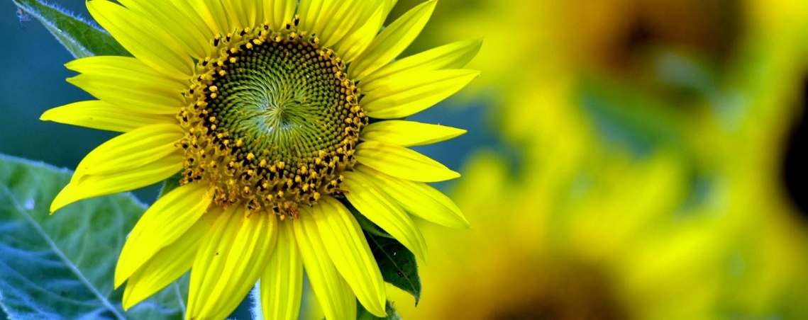

Young people are trained to carry on established traditions. Without question, they enter the fire and help keep it burning.
Humanity remains largely unaware of a deeper condition: the sum of human thought is a collective force that is everywhere at once. It reinforces the assumptions that sustain the human agenda - to live for its own sake, as if life has no other purpose.
This psychological phenomenon remains unknown because our highest forms of thinking are inevitably washed back into the collective thought, like waves returning to the ocean.
"You are not a wave on the ocean: you are the ocean in a wave." - Rumi
Collectively, we protect the energetic and psychological integrity of the individuals who constitute the whole. Few recognize the extent to which the field of thought shapes perception, identity, and destiny.
Energy is a condition of positive/negative alternation - one eternal particle repeating until it rationalizes the primal resistance that initiated it. The primal trinity: positive, negative, and the resistance that caused the separation are compelled thermodynamically to continue recycling until the denizens of fire see the spark within and are enlightened to the fact that all things are accumulations of the same spark.
Science has produced extensive work focused on the eternal spark, yet consensus has never aligned with recognition of the collective whole - the presence, the force that emerges from humanity itself: THE EMERGENT PRINCIPAL.
We are all separate fires from the same spark re-igniting in an attempt to become rea. This can never happen because movement is illusion. Period.
Young people keep the fire burning as old logs are consumed, ensuring continuity. We are obliged to apply ourselves to the fact of our eternal recurrence: the spark disappearing into the void, the entire universe disappearing with it at the speed of gravity.
This was qualified by Isaac Newtom, quantified by Max Planck, proven by Mileva Maric, and given practical purpose by Nikola Tesla.
We are ignited by the same spark, and we return to Eternity by discovering that spark within ourselves.
This is too simple for intelligent sparks to accept.
The collective presence must first be recognized before it can be included as an essential part of university education. This is the stumbling block - the challenge to overcome our natural desire to live for its own sake, in direct contravention of becoming who we are in reality.
The sum of who we think we are, is a watchdog; a force that is everywhere at once in control of all that it is. This anomaly is our own creation and is the mountain we must climb.
"The whole is more than the sum of its parts." - Aristotle
All-as-one, we are the sum of our parts. Each part of the whole is the same eternally recurring particle gathering into rocks of thinking. The movies of life are simply the same particle repeating with a different face. When the negative sees its positive face, Eternity/Love will reveal and momentum will change.
We enter the fire to find the spark within.
We are fire and spark.
Cause and effect.
-----------------------------------
Caption
Humanity continually feeds the collective fire of becoming, unaware that every individual flame is the same eternal spark seeking itself.
-----------------------------------
REFERENCES
Heraclitus: fire, flux, becoming.
Aristotle: emergence and wholes.
Nietzsche: eternal recurrence.
Jung: collective psyche and archetypes.
Nikola Tesla: energy, vibration, resonance.
G. I. Gurdjieff: awakening from mechanical existence.
Thermodynamics: cyclic processes and energetic transformation.
Systems Theory: wholes emerging from interacting parts.
Collective Consciousness Studies: shared psychological fields.

