FREE ENERGY
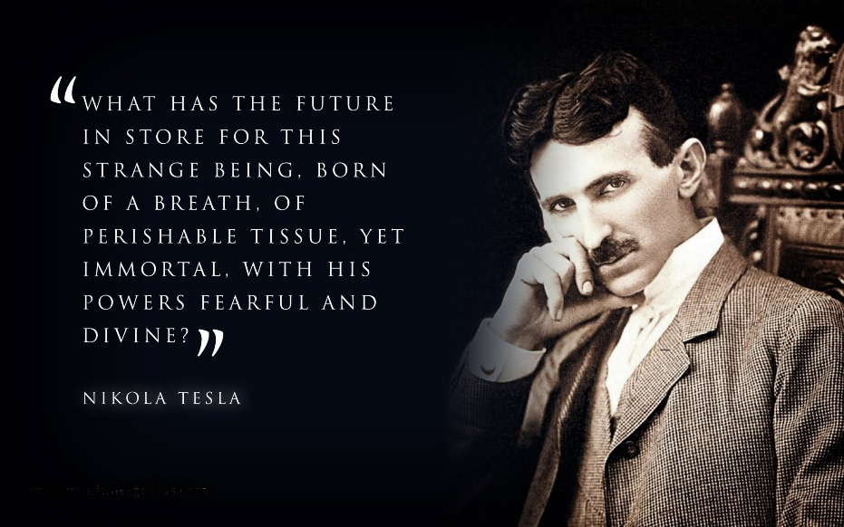

The blueprint of the universe is a machine that draws its energy from the bottomless well of Eternity.
Eternity is One. One is Nothing. Consequently, energy is free.
Energy is available on demand, and because it is freely given, we rarely think about it. We do not question the rain. We do not question the snow. We simply receive.
Max Planck determined that energy is non-linear and appears in discrete amounts, or quanta.
Each energy packet returns to Eternity to refill.
Nikola Tesla used this understanding to fuel the Industrial Revolution.
He claimed that because energy is free, it can be harnessed, and further claimed that in times to come, humanity would draw energy directly from the air.
Tesla's greatest invention, perhaps, was the commutator, where he effectively emulated a working facsimile of a linear-to-cyclic environment: a generator.
Tesla took what was already happening and plugged into it.
All of his inventions are based upon the fact of free energy.
---------------------------------
REFERENCES
Isaac Newton
"Nature is pleas'd with simplicity, and affects not the pomp of superfluous causes."
Newton sought underlying unity behind the apparent complexity of the world. His work revealed the same eternally recurring movement at the center of being. He expressed it as F = ma, perhaps the simplest and most elegant equation ever conceived.
Max Planck
The discovery of energy quanta revealed that energy is not expressed as a continuous flow but appears in discrete packets.
Planck's quantum hypothesis transformed our understanding of the universe from a purely linear event into a cyclic-to-linear process, a generator continually converting Eternity into manifestation.
Nikola Tesla
"We are whirling through endless space... everywhere there is energy."
"All peoples everywhere should have free energy sources."
Tesla knew that humanity's future depended upon harnessing the abundant energies already present in nature.
He understood that power need not be created. It need only be accessed.
G. I. Gurdjieff
Gurdjieff's Law of Three, also called the Triamazikamno, describes the universal process by which all new events and transformations occur through the interaction of three independent forces.
In Beelzebub's Tales to His Grandson, these forces are presented as fundamental to creation itself.
The Law of Three:
Positive
Negative
Resistance
Positive, Negative, and Resistance form the trinity underlying the recurring quanta.
The Tao Te Ching
"The Dao produced One; One produced Two; Two produced Three; Three produced All Things."
The Tao is the unnamable source from which multiplicity emerges and to which all things remain connected.
It is the silent foundation beneath becoming.
-----------------------------------
Tesla's Question
"What has the future in store for this strange being, born of a breath, of perishable tissue, yet immortal, with his powers fearful and divine?"
— Nikola Tesla
----------------------------------
CLOSING STATEMENT
From the Tao emerges the One Positive.
From the One Positive emerge the Two: Positive and Negative.
From the Two is revealed their Cause: Resistance.
Positive. Negative. Resistance.
From these Three emerge all things.
Newton revealed movement as an Eternal Flash of Energy.
Planck revealed the eternally recurring quanta.
Tesla revealed abundance.
Gurdjieff revealed the Law of Three.
Each, in his own language, pointed toward the same conclusion:
The universe is not founded upon scarcity, but upon an inexhaustible source.
The ancients called it the Tao.
The mystics called it the Absolute.
I call it Eternity.
From Eternity comes energy.
To Eternity energy returns.

