SRI YANTRA: The Eternal Generator
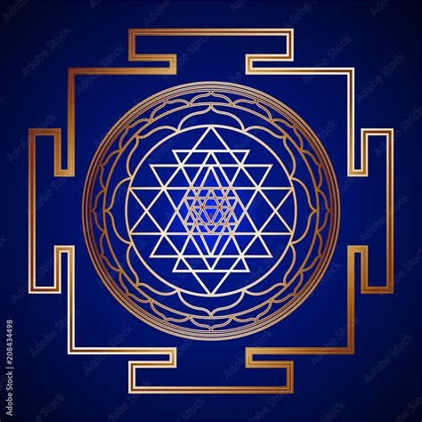

How One Became Two So That Two Could Become One
IN THE BEGINNING
The first pulse of time was an energetic default:
Eternity twisted into a point of view, a perfect duality; complementary opposites, a positive and a negative.
The birth of energy.
Enter the Adam & Eve myth to fill a need.
The primal duality came to play but drifted further apart; the negative pursuing its original cause, the positive longing to return home.
The negative cannot fly on one wing.
As the universe evolves its positive wing answers every demand with perfection.
It is our reactions that measure need, and so we torture ourselves until we rationalize the resistance we insist upon.
We are guided every step of the way.
The positive and negative are the first particle of energy and one cannot come home without the other.
There is no separation, only fragmentation.
The positive enacts the physics of return through every living thing. Like Ohm's Law, all things equal when resistance is reconciled.
God's absolute awareness in energy is the One Positive.
"For God so loved the world, that he gave his only begotten Son, that whosoever believeth in him should not perish, but have everlasting life."
John 3:16
-------------------------------------
References & Influences
Yin-Yang (Taoist Polarity)
Yin and Yang represent complementary opposites whose interaction generates and sustains the manifest world. They are interdependent rather than antagonistic. [britannica.com], [en.wikipedia.org]
The familiar symbol (Taijitu) illustrates that each polarity contains the seed of the other, emphasizing dynamic balance rather than static opposition. [philosophy.institute], [followthetao.com]
Sri Yantra (Sacred Geometry)
The Sri Yantra consists of nine interlocking triangles: four upward-pointing (traditionally associated with Shiva) and five downward-pointing (associated with Shakti), symbolizing the union of complementary forces. [satyori.com], [en.wikipedia.org]
The intersection of these triangles creates 43 smaller triangles around a central bindu, representing the emergence of multiplicity from unity.
Nikola Tesla
Tesla's work centered on energy, resonance, oscillation, and electrical polarity. His investigations into frequency and vibration continue to inspire philosophical interpretations of an energetic universe. [techhistorylab.com]
The popular quote, "If you want to find the secrets of the universe, think in terms of energy, frequency and vibration," is widely attributed to Tesla, though modern researchers note the attribution is uncertain. [rorycallaghan.com], [infinitelysimple.org]
G. I. Gurdjieff
Gurdjieff's "Law of Three" describes creation as arising through the interaction of three forces: affirming, denying, and reconciling. [gurdjieff.in], [The Law of...ess Search], [ggurdjieff.com]
This triadic model parallels many ancient symbolic systems in which apparent opposites require a third force to produce transformation. [cac.org], [gurdjieff.in]
Additional Related Sources
Tao Te Ching (Lao Tzu)
I Ching (Book of Changes)
The Kybalion (Principle of Polarity)
In Search of the Miraculous by P.D. Ouspensky (Gurdjieff's teachings)
Beelzebub's Tales to His Grandson by G.I. Gurdjieff
The Tao of Physics by Fritjof Capra
Man and His Symbols by Carl Jung
The Marriage of Heaven and Hell by William Blake

