WILD HORSES
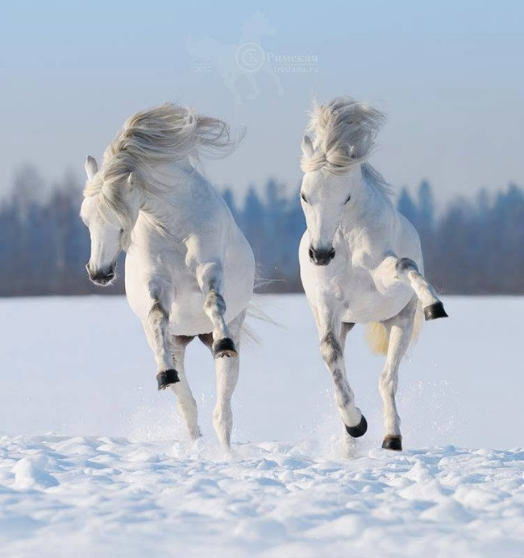

Eternity twisted to a point of view, instantly regretted, but the gate was open and the escape from freedom had begun.
The point of view is a state of tension: positive and negative. Yet only the negative poured outward.
The energetic universe is a growing mass driven by its own momentum. Positive awareness is sacrosanct. It flies alongside, for the negative cannot exist alone. The positive answers every turn of the eternal wheel with absolute clarity, as the gathering mass continues to snowball.
And so it is. We began from a point of view and now we are chasing ourselves through time in order to recover. Supported at every turn of the eternal wheel by our own perfection. But the ground is fallow, there is no harvest to reap, and the few that germinate are overwhelmed by the collective mass.
A reverse culling.
One is All
The names differ. The insight remains.
----------------------------------
ECHOES OF THE ONE
Eight voices, separated by centuries and traditions, yet united by a common intuition: beneath the appearance of separation lies a deeper unity awaiting recognition.
Plotinus • Blake • Eliot • Rumi • Lao Tzu • Jung • Gurdjieff • Teilhard de Chardin
Plotinus
"I am striving to give back the Divine in myself to the Divine in the All."
Perhaps the single best summary of One is All.
William Blake
"If the doors of perception were cleansed every thing would appear to man as it is, Infinite."
The perfect companion to "Eternity twisted to a point of view."
T. S. Eliot
"We shall not cease from exploration, and the end of all our exploring will be to arrive where we started and know the place for the first time."
A profound expression of return and recovery.
Rumi
"You are not a drop in the ocean. You are the entire ocean in a drop."
The individual contains the whole, just as the whole is reflected in the individual.
Lao Tzu
"Returning is the movement of the Tao."
Possibly the most concise statement ever written about the cosmic cycle of departure and return.
Carl Jung
"The privilege of a lifetime is to become who you truly are."
The psychological expression of remembering who one truly is.
G. I. Gurdjieff
"Man is asleep. Man does not have real consciousness or will at all."
A direct challenge to collective momentum and unconscious living.
Pierre Teilhard de Chardin
"We are not human beings having a spiritual experience; we are spiritual beings having a human experience."
A reminder that evolution is not merely material. Consciousness itself is part of the journey.
-------------------------------
The wheel turns. The center remains.

